**APPC, Mechanics: Unit  HW 3** Name: ________________________________________

Hr: ____ Due at beg of hr on: ______________

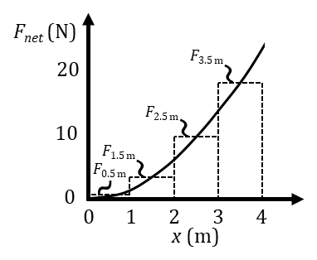U, HW3, P1

Reference Videos: (1) “The Work Done by a Varying Force”

(2) “Work Done on an Object by a Varying Force”

YouTube, lasseviren1, WORK, ENERGY, AND POWER playlist

Until now, any time we’ve dealt with work, we’ve assumed that the force is

constant. Here, we address the case of work done by a force that is changing.

Above-right is a graph showing how a force changes smoothly and continuously with displacement. The

graph conforms to the equation $F\left(x\right)=\frac{3}{2}x^{2}$. Several rectangles are shown; we’ll get to those in a minute.

A. Suppose we want to know the work done by the force between *x* = 0 m and *x* = 4 m.

What feature of an *F*-*x* (or *F*-*s*, whatever…) graph will give us this quantity?

B. One way to approximate your Part A answer is divide the graph into rectangles. Here, see that each rectangle’s height is the force at the “x.5” m displacements. What is the width of each rectangle?

C. Write out the equation, with ALL terms, that approximates what you stated in your Part A answer. Use

given heights (i.e., the variables) from the graph as well as your Part B answer. Label the left side of the

equation according to the physical

quantity you are calculating.

HINT: You will need three (+) signs.

D. What about the rectangles shown will result in your Part C answer yielding a good approximation to your Part A answer? HINT: Look at the graph’s curve and how the rectangles ‘interact’ with it.

E. Recall that, here, the actual equation of the graph is $F\left(x\right)=\frac{3}{2}x^{2}$. Now, use a calculator to evaluate your Part C answer. Do NOT round, for any calculation you make. Include the correct unit on your answer.

F. In approximating our Part A answer using the method of rectangles, what would

happen to our accuracy if we were to use more – but narrower – rectangles?

G. Our ACTUAL Part A answer would be found if we used HOW MANY rectangles?

H. State the thickness/width that each Part G rectangle would need to have.

I. Your Parts G and H answers are most easily accomplished by doing what, to *F*(*x*)?

J. Carry out your Part I answer here. Recall that we want to know

the work done by the force between *x* = 0 m and *x* = 4 m.

K. Comment on how your Parts E and J answers compare.

L. Now, determine the work done by the force between *x* = 2 m and *x* = 4 m.

M. In Part J, the displacement is exactly twice what it is in Part L. Why, then, ISN’T your Part J answer exactly twice your Part L answer?

U, HW3, P2

Reference Video: “Power and Efficiency”

YouTube, lasseviren1, WORK, ENERGY, AND POWER playlist

A. Use English WORDS

to write two “equations” $P_{avg}=$ $P_{avg}=$

for average power.

B. Use calculus-type variables to write two

equations for instantaneous power. $P_{inst}=$ $P_{inst}=$

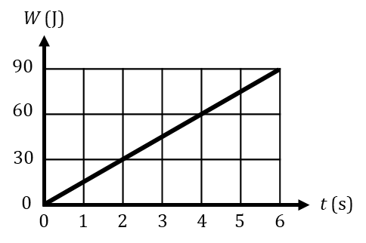

C. Use the graph at right in conjunction with your answers above to deter-

mine the power being expended at any instant between *t* = 0 s and *t* = 6 s.

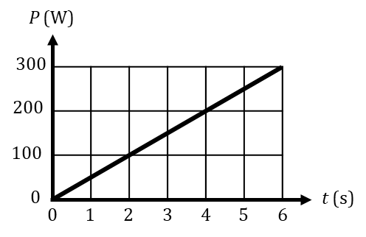

D. Use the graph at right to find the work done between *t* = 1 s and *t* = 4 s.

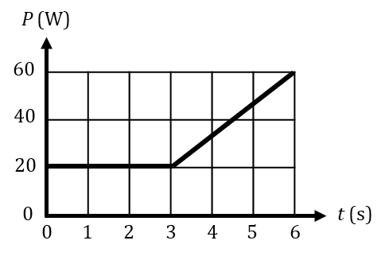

E. Use the graph at right to find the work done between *t* = 2 s and *t* = 5 s.

F. The graph shown here applies to the function $P\left(t\right)=6t^{2}-4t+5$. Find the work done between:

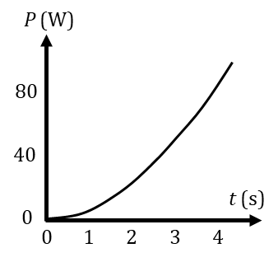i. *t* = 0 s and *t* = 2 s ii. *t* = 0 s and *t* = 3 s iii. *t* = 2 s and *t* = 3 s

G. With regard to your Part F answers…You perhaps can see that, if you want to find the area under a function between a lower bound of *x* = *A* and an upper bound of *x* = *B*, in effect what you are doing is finding the area between *x* = _____ (fill this blank in!) and *x* = *A*, then finding

the area between *x* = _____ (this blank, too!) and *x* = *B*, and then…doing what?

H. Write the two equations for

efficiency given in the video. $e=$ $e=$

I. The transitive property says that you can equate the right sides of the two equations you wrote in your Part H answer. But, beyond that trivial result, WHY IS IT that those two “right sides” really are exactly equal to each other? HINT: It has to do with units.

U, HW3, P3

Reference Videos: (1) “Conservative and Non-Conservative Forces”

(2) “Conservative and Non-Conservative Forces, Part II”

YouTube, lasseviren1, WORK, ENERGY, AND POWER playlist

A. With **conservative forces**, it is ____________ to get energy back out of the system; with **non-conservative forces**, it is __________________. With BOTH types of forces, energy __________________ _________.

B. When displacing an object from one specific point to a different

specific point, the work done by a conservative force is…

The figures show a 4 kg mass being moved. In Figure I, which deals with gravity, our view is from the SIDE; the mass moves up, down, and horizontally. In Figure II, which deals with friction, the mass moves ONLY in the horizontal plane; we are LOOKING DOWN on the action. For convenience, the coordinate systems match. In all cases, the mass will start at (0, 0) and end at (3, 4). All coordinates are in meters.

C. If *g* = 10 m/s2, what is the force of gravity on this mass?

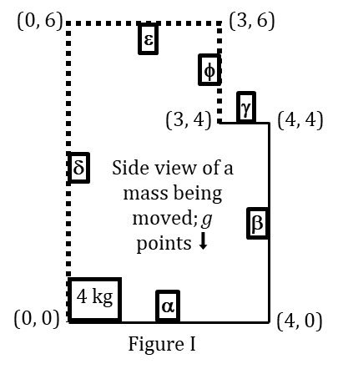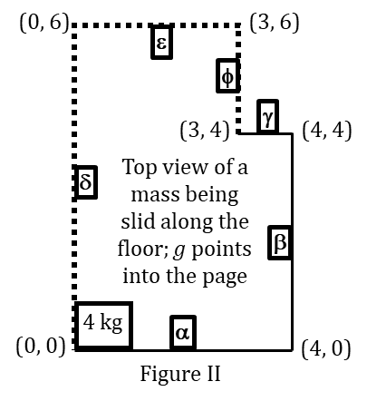

In Figure I, the mass moves from (0, 0) to (3, 4) via two different paths.

D. Find the work done by gravity as the mass traverses segment:

i.  ii.  iii. 

E. Now find the work done by gravity as the mass traverses segment:

i.  ii.  iii. 

F. How do the sums of your Parts D and E answers compare?

Turn now to Figure 2. Assume the friction force is always 4 N.

G. Find the work done by friction as the mass traverses segment:

i.  ii.  iii. 

H. Now find the work done by friction as the mass traverses segment:

i.  ii.  iii. 

I. How do the sums of your Parts G and H answers compare?

J. Based on your answers to Parts B, F, and I, label

these forces as ‘conservative’ or ‘non-conservative’.

i. gravity ii. friction

K. In addition, the work done by any

conservative force over a **closed path**…

L. Look again at both figures. If the mass proceeds CCW around the

entire loop, starting at (0, 0) and ending at (0, 0), verify by

calculation that your answers to Parts J and K are in agreement with regard to each type of force:

i. gravity ii. friction

U, HW3, P4

Reference Video: “Work Done by a Conservative Force”

YouTube, lasseviren1, WORK, ENERGY, AND POWER playlist

A. Write the most basic equation involving the work done by a conservative force and the

change in potential energy. HINT: Your answer should have only one ‘equals’ sign.

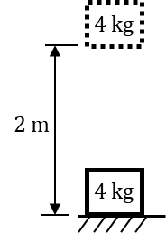

B. With reference to the figure, corroborate your Part A answer by determining the:

i. work done by gravity in raising the mass

ii. change in potential energy when the mass is raised

iii. work done by gravity in lowering the mass

iv. change in potential energy when the mass is lowered

C. From the video, write the equation relating a conservative force, work done by that force, the change in potential energy, and displacement. HINTS: You need two

(=) signs, one integral, one differential, and the dot product.

D. Differentiate your entire Part C answer to obtain an equally-applicable equation.

HINTS: You’ll need two (=) signs, three

differentials, and the dot product.

E. If you ignore the ‘work’ part of your Part D answer and rearrange the rest, you will see that a conserv-ative force is the ___________________ derivative of the ________________________ _______________ with respect to position. Thus, on a graph of ________________________ _______________ versus position, the force at any particular position is found to be the ___________________ ____________ of the graph at that position.

F. Refer to the figure at right. Circle ALL correct answers.

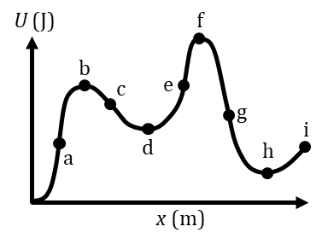 i. *F* is large and (+) at point(s)………………………… a b c d e f g h i

ii. *F* is equal to zero at point(s). ………………………. a b c d e f g h i

ii. *F* is moderate and (–) at point(s).………………... a b c d e f g h i

iv. Point(s) of **stable equilibrium** is/are.……….. a b c d e f g h i

v. *F* is moderate and (+) at point(s).………………... a b c d e f g h i

vi. *F* is large and (–) at point(s).………………………. a b c d e f g h i

vii. Point(s) of **unstable equilibrium** is/are…… a b c d e f g h i

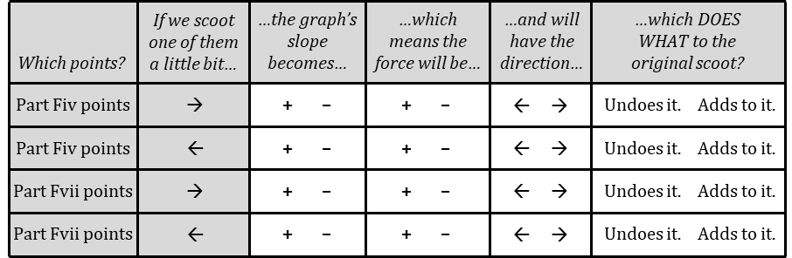G. Let’s look at your Parts Fiv and Fvii answers. Since our conservative force and displacements are acting in only 1-D, let’s take 🡪 to be (+) and 🡨 to be (–). In the unshaded portions of the table, circle your answers.

U, HW3, P5

Reference Videos: (1) “Physics of Elevators”

(2) “Newton's Law of Motion Review (Part I)”

YouTube, lasseviren1, NEWTON’S LAWS OF MOTION playlist

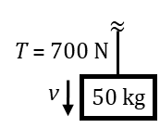NOTE: As always, you are advised to use *g* = 10 m/s2, to essentially eliminate any need for a calculator.

A 50 kg metal crate is moving downward. It is attached to a heavy cable that, at the

moment in question, has a tension of 700 N.

A. Draw an FBD and determine the magnitude

and direction of the crate’s acceleration.

B. As the crate descends, is it speeding up or slowing down? Briefly explain your answer.

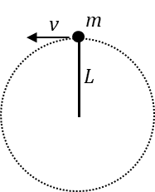

C. A 2 kg stone attached to a 4-m rope is being whirled in a vertical circle. At the top, the speed of the stone is 8 m/s. Draw an FBD and deter-mine the tension in the rope. See the figure.

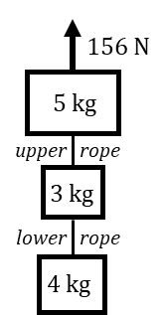D. Suppose the stone in Part C is still moving at 8 m/s when it reaches the bottom of its path. Again, draw an FBD and determine the tension in the rope.

A three-block system is being raised upward, against gravity. See the figure at right.

E. Determine the tension in the upper rope AND the lower rope.

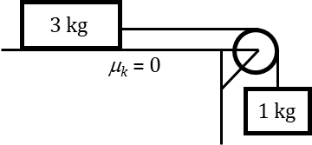

F. For the system shown, find the acceleration of the system and the string’s tension.

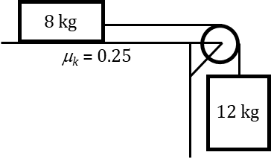

G. For the system shown, find the acceleration of the system and the string’s tension.

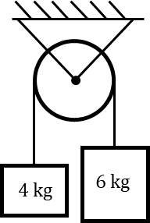

H. For the system shown, find the acceleration of the system and the string’s tension.