**APPC, Mechanics: Unit  HW 4** Name: ________________________________________

Hr: ____ Due at beg of hr on: ______________

U, HW4, P1

Reference Videos: (1) “Review of Newton's Laws of Motion (Part II)”

(2) “Review of Newton's Laws of Motion (Part III)”

YouTube, lasseviren1, NEWTON’S LAWS OF MOTION playlist

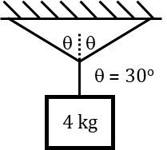

A. With reference to the figure at right…

i. What is the VERTICAL component of

the tension in each angled rope?

ii. What is the overall tension in each slanted rope? (NOTE the 30-60-90 right triangles…)

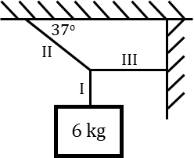B. Use the diagram at right to determine the tension in Ropes I, II, and III.

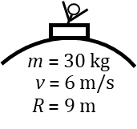C. A child in a sled slides over the top of a snowy hill. Draw an

FBD and determine the normal force of the hill on the sled.

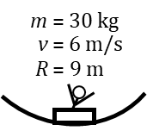

D. Now, the child is at the bottom of the next valley. Draw an

FBD and determine the normal force of the hill on the sled.

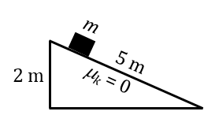

E. Determine the acceleration of the mass down the frictionless plane. Draw an

FBD, and then report your final answer in terms of some fraction of *g*.

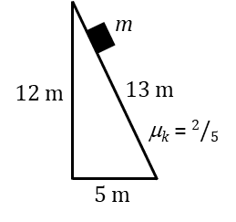F. Determine the mass’s acceleration in this last figure. Note that there IS friction, this

time. Draw an FBD and report your answer in terms of some fraction of *g*.

U, HW4, P2

Reference Video: “Review of Work, Energy, and Power (Part I)”

YouTube, lasseviren1, WORK, ENERGY, AND POWER playlist

A. Determine the work done when a force $\vec{F}=-2 N \hat{i}+5 N \hat{j}-1 N \hat{k}$

acts over a displacment $\vec{s}=-5 m \hat{i}-2 m \hat{j}+3 m \hat{k}$.

B. Based on the sign of your Part A answer, is the angle between the vectors **acute** or **obtuse**?

C. Determine the magnitude of: i. $\vec{F}$

ii. $\vec{s}$

D. i. Use your Parts A and C answers to determine the angle

between the vectors $\vec{F}$ and $\vec{s}$. Refer back to Part A of

HW2, P5, if you’ve forgotten the equation that applies.

ii. Does your Part Di answer corroborate your Part B answer?

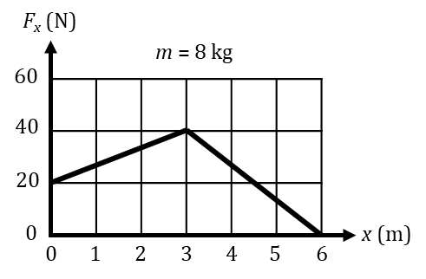

Use the graph to answer the next two questions.

E. Determine the work done between *x* = 0 m and *x* = 6 m.

F. If the object’s initial speed is 4 m/s, determine its speed at *x* = 6 m.

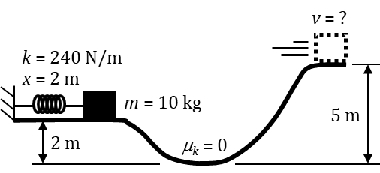G. The figure shows a spring launching a mass from rest. The mass slides along the frictionless surface. Determine the mass’s speed at the top of the hill.

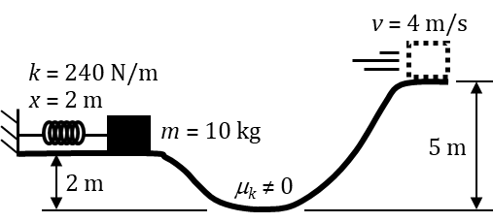H. In the last figure, the scenario is repeated, except now there IS friction and the mass’s speed at the top of the hill is measured to be 4 m/s. Determine the work done by friction.

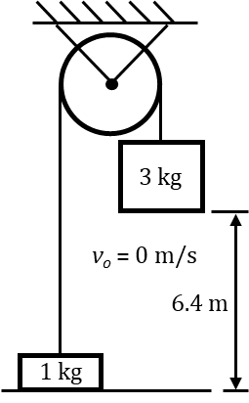U, HW4, P3

Reference Video: “Review of Work, Energy, and Power (Part II)”

YouTube, lasseviren1, WORK, ENERGY, AND POWER playlist

A. Determine the speed with which the 3 kg mass hits the floor.

B. A 2 kg mass moves in accord with the velocity-time function $v\left(t\right)=6t^{2}-6t-5$.

At time *t* = 0 s, the mass is at position *x* = 0 m. Determine the:

i. initial velocity

ii. position at *t* = 3 s

iii. net force at *t* = 3 s

iv. work done on the mass between *t* = 0 and *t* = 3 s

v. power being expended at *t* = 3 s

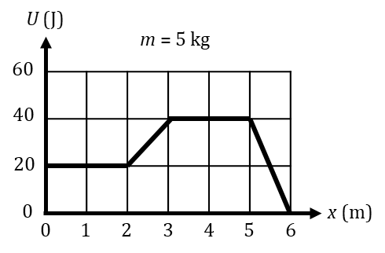

Based on the graph at right, answer the following questions.

C. Determine the net force on the mass at:

i. *x* = 1.5 m iii. *x* = 3.5 m

ii. *x* = 2.5 m iv. *x* = 5.5 m

D. At what specific time (OR time interval, whichever

applies here) must the mass have its greatest speed?

E. Explain briefly your Part D answer.

F. Suppose at this point that you are told that, at some specific time (OR time interval, whichever applies here), the mass is at rest. This being the case, determine the value of the maximum speed that relates to your Part D answer.

U, HW4, P4

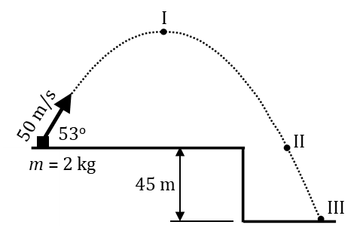Reference Video: “Review of Work, Energy, and Power (Part III)”

YouTube, lasseviren1, WORK, ENERGY, AND POWER playlist

A. Determine the following quantities. Assume *g* = 10 m/s2 and that air

resistance is negligible. You will NOT need a calculator for Part A.

i. time to reach I

ii. velocity at I

iii. height above launch point, at I vii. horizontal range, from launch to III

iv. time to reach II

viii. work done by gravity between launch and III

v. velocity at II

vi. time to reach III

B. Determine the mass’s kinetic energy at launch AND at III.

C. Show that your answers to Parts Aviii and B

conform to the work-energy theorem.

D. A potential energy vs. position function is $U\left(x\right)=-3x^{2}+4x-2$. The object is a 2 kg mass.

i. Determine the force on the mass AND the mass’s acceleration when it is at the position *x* = 2 m.

ii. Determine the position at which

there is zero force on the mass.

iii. Is your Part Dii answer a point of *stable* or *unstable* equilibrium? Show justification for your claim.

HINT: You need to figure out what the *U*(*x*) function is doing on either side of your Part Dii answer.

E. For the situation where the graph applies, it has been determined that the system’s total energy is 40 J.

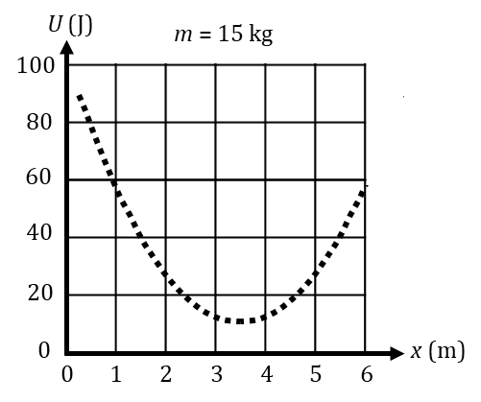 i. State why the mass CANNOT reach the position of *x* = 1 m.

ii. The two boundary *x*-values for the actual motion of the mass are

the lower bound of *x* = _____ m and the upper bound of *x* = _____ m.

iii. (CIRCLE) In which direction does the force act on the mass…

a. at the lower bound 🡨 🡪 b. at the upper bound 🡨 🡪

iv. The mass is released from rest at *x* = 1.5 m. Find *v*max AND the position where *v*max occurs.

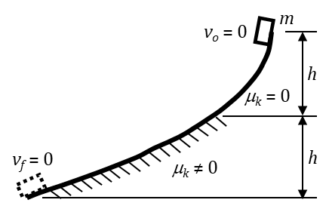U, HW4, P5

Reference Video: “Review of Work, Energy, and Power (Part IV)”

YouTube, lasseviren1, WORK, ENERGY, AND POWER playlist

In the figure at right, a mass is released from rest at the top of a slope.

Initially, the slope is frictionless; friction begins to act only when the

mass has fallen halfway down to its final elevation. The mass eventually

comes to rest at the point where it is shown as a dashed object.

A. Derive an expression for the speed of the

mass after it has fallen a vertical distance *h*.

B. Why does the normal force do zero

work, in bringing the mass to rest?

C. For the entire trip, how much work does gravity do on the mass?

D. For the entire trip, how much work does friction do on the mass?

E. Justify your Part D answer. In your response, make reference to the work-energy theorem.

F. A force vs. position function is $F_{net}\left(x\right)=8x^{3}-3x^{2}-4x+1$. The object is a 4 kg mass.

i. Determine the mass’s acceleration at position *x* = 1 m.

ii. Determine the work done by the

force between *x* = 0 m and *x* = 2 m.

iii. If the mass had *vo* = 0 m/s at *x* = 0 m, determine its speed at *x* = 2 m.

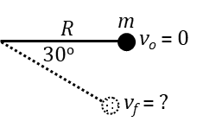

G. A mass *m* is attached to a rod of negligible mass and length *R*. The rod is initially horizontal and the system is at rest. The mass is dropped and the rod rotates about its pinned left end. Derive an expression for the speed of the mass at the moment when the rod passes through the 30o angle shown in the figure.

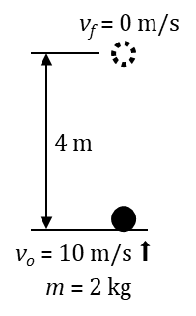

H. A 2 kg mass is launched upward, with *vo* = 10 m/s. It reaches a height of 4 m. Air

resistance is NOT negligible. Between launch and the top, determine the following:

i. the net work done on the mass

ii. the work done by gravity

iii. the work done by the friction of air resistance