**APPC, Mechanics: Unit  HW 1** Name: ________________________________________

Hr: ____ Due at beg of hr on: ______________

U, HW1, P1

Reference Videos: (1) “Momentum Basics”

(2) “Momentum and Types of Collisions in Physics”

(3) “Types of Collisions in Physics (Part II)”

YouTube, lasseviren1, MOMENTUM playlist

A. In the first video, the narrator tells us that the *prime* symbol, i.e. **‘** , means…

B. Write the simplest equation for the conservation of total momentum.

Use ONE prime symbol and TWO vector symbols in your answer.

C. The equation you wrote in your Part B answer holds only if the ______ force on the system is __________.

D. For each type of collision, circle ALL correct answers.

i. elastic ii. perfectly (or completely) inelastic iii. (partially) inelastic

mechanical energy conserved mechanical energy conserved mechanical energy conserved

momentum conserved momentum conserved momentum conserved

objects bounce off each other objects bounce off each other objects bounce off each other

objects stick to each other objects stick to each other objects stick to each other

E. In each scenario below, a mass approaches a wall. For each type of collision, do the following:

i. Next to the mass at *t*2, write the type(s) of energy present AND how many joules of each. In some

cases, you may need to MAKE UP reasonable values for energies; any possibly-true values are fine.

ii. Draw WHERE the mass would be at *t*3. Again, write the type(s) of energy and how much of each.

elastic perfectly (or completely) inelastic (partially) inelastic

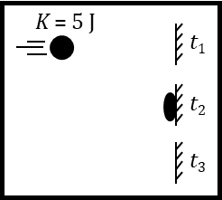

F. When using momentum conservation, there ARE forces exerted on various parts of the system. How-ever, these are _____________________ forces; therefore, the *Fnet* ON the entirety of the system is still ________.

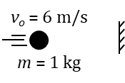G. Based on the figure, determine the CHANGE in the mass’s momentum if:

i. the mass sticks to the wall ii. the mass bounces back with a speed of 3 m/s

U, HW1, P2

Reference Video: “Collisions in Two Dimensions”

YouTube, lasseviren1, MOMENTUM playlist

A. Write equations for the following statements. You’ll need TWO vector symbols for each answer.

i. “Net force is the time-rate-of-change of momentum.”

ii. “Net force in the *x*-direction is the time-rate-of-change of momentum in the *x*-direction.”

iii. “Net force in the *y*-direction is the time-rate-of-change of momentum in the *y*-direction.”

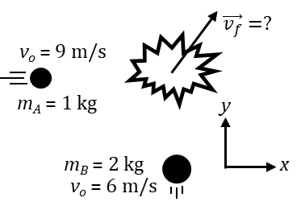B. To summarize Part A: If there is a net force on a system, then the momentum of the system will be ______________________ with time; that is, the momentum of the system will be either ________________________ or ________________________ as time goes on. On the other hand, if the net force on a system IS zero, then the time-rate-of-change of momentum is __________, which means that ‘earlier’ and ‘later’ momenta are ____________. Only in this latter case is momentum ___________________________.

C. In the figure at right, two masses eventually collide in a completely inelastic collision. Determine each quantity below, showing your work.

i. *x*-momentum before the collision

ii. *y*-momentum before the collision

iii. Use your Part Ci answer to help you determine the *x*-comp-

onent of the combined mass’s velocity after the collision.

iv. Use your Part Cii answer to help you determine the *y*-comp-

onent of the combined mass’s velocity after the collision.

v. Use your Parts Ciii and Civ answers to deter-

mine $\vec{v_{f}}$ (both magnitude and direction).

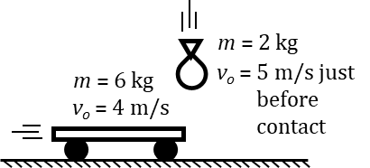

D. Circle your answers below. Assume ZERO friction between the cart and the floor.

We wish to find the final velocity of the *cart-bag system*. Therefore, the

**cart bag floor** is NOT a part of the system. What this means is that

(look at the picture!), any force that is exerted ON the **cart bag floor** BY the **cart bag floor** OR ON the **cart bag floor** BY the **cart bag floor** is NOT relevant to the analysis. The irrelevant forces you dealt with in the previous sentence act in the ***x y*** direction; therefore, in this collision, momentum will be conserved ONLY in the ***x y*** direction. To be clear, there ARE forces acting in the direction of momentum conservation, but these are **internal external** forces.

E. Now, determine the final velocity of the cart-bag system.

U, HW1, P3

Reference Video: “Ballistic Pendulum Problems”

YouTube, lasseviren1, MOMENTUM playlist

A. According to the narrator, WHY – in ballistic pendulum problems – can you NOT use energy conservation exclusively? I.e., Why, at some point, MUST you use conservation of momentum?

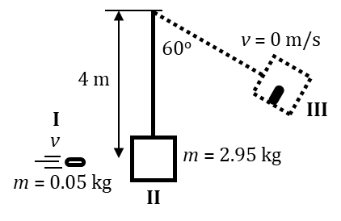

B. A bullet approaches the block of a ballistic pendulum at some unknown speed. Our ultimate goal is to determine this unknown speed. The bullet embeds in the block and the combination mass rises, as depicted. Somewhat ironically, *we will work backwards in time*...

i. What is the total mass at Point III?

ii. We now wish to find the ‘initial’ speed of the combined mass at Point II, just after the bullet has

embedded in the block and as the combined mass begins to swing toward Point III. Since the

collision has already happened AND because there is no friction

between Points II and III, we will use conservation of…

iii. Carry out your Part Bii answer and find the speed of the combined mass at Point II.

iv. Now, let’s start to find the incoming speed of the bullet, at Point I. To analyze

the bullet slamming into the block, we will have to use conservation of…

v. Explain your Part Biv answer. Why do we need THAT conservation law instead of some other?

vi. Use your answers to Parts Biii and Biv to determine the incoming speed of the bullet.

vii. Determine the number of joules of internal (basically, thermal) energy that are generated in the

collision between the bullet and the block.

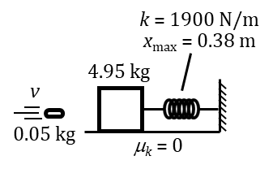

C. In this figure, the bullet becomes embedded in the block and then the spring

compresses. Again, *work backwards* in determining the following quantities:

i. the speed of the combined mass just before the spring starts to compress

ii. the speed of the incoming bullet

iii. the internal energy generated by the collision between the bullet and the block

U, HW1, P4

Reference Videos: (1) “Rotational Kinematics”

(2) “Rotational Kinematics (Part II)”

YouTube, lasseviren1, ROTATIONAL MOTION playlist

A. A **radian** is the angle subtended when, for example, a point on a circle has rotated (to a new location) through an arc length that is equal to the circle’s __________________.

|  |  |  |
| --- | --- | --- |
| Variable | Name of the quantity | Unit |
| $$\vec{θ}$$ |  |  |
| $$∆\vec{θ}$$ |  |  |
| $$\vec{ω}$$ |  |  |
| $$\vec{α}$$ |  |  |

B. Complete the table at right.

|  |  |  |
| --- | --- | --- |
| Variable | Specific name of the quantity | Equation |
| $${\vec{ω}}_{avg}$$ |  |  |
| $${\vec{ω}}_{inst}$$ |  |  |
| $${\vec{α}}_{avg}$$ |  |  |
| $${\vec{α}}_{inst}$$ |  |  |

C. Complete the table at right.

D. Below the four Kinematics Equations shown, write each equation’s rotational analog.

$v_{f}=v_{o}+at$ $∆x=\frac{1}{2}\left(v_{f}+v_{o}\right)t$ $∆x=v_{o}t+\frac{1}{2}at^{2}$ $v_{f}^{2}=v_{o}^{2}+2a∆x$

E. What condition MUST be satisfied, in order to use the equations you wrote in your Part D answers?

F. An object is rotating at an initial angular velocity of +2 rad/s and has a constant angular acceleration of +3 rad/s2. Showing your work, determine, after 4 seconds have elapsed, the:

i. final angular velocity

ii. angular displacement

G. How many revolutions has the object of Part F made, in the 4 seconds mentioned?

U, HW1, P5

Reference Video: “Rotational Kinematics (Part II)”

YouTube, lasseviren1, ROTATIONAL MOTION playlist

A. Write the “Bridge Equations” that connect linear (or *translational*, or *tangential*) and rotational motion.

i. displacement: ii. velocity: iii. acceleration:

B. An object rotates in accord with the position-time function $θ\left(t\right)=2t^{3}-t^{2}-7t+3$. Determine the:

i. angular velocity at *t* = 2 s

ii. angular acceleration at *t* = 1 s

C. Can the angular forms of the four Kinematics Equations

(see HW1, P4, Part D) be applied to the object in Part B? (circle) YES NO

D. Briefly explain your Part C answer.

E. We have dealt with centripetal acceleration *ac* a lot, particularly in our study of Newton’s 2nd law.

To review, write the simple equation we have always used for *ac* , up to this point, i.e., *ac* = ?

F. Substitute the right side of your Part Aii answer into your Part E answer, then simplify.

This gives you another equation you can use to find centripetal acceleration *ac*.

G. Circle your answers below. In each case, assume that the object IS rotating.

i. If ** = 0, then ** is: constant and zero constant and nonzero continuously changing

ii. If ** ≠ 0, then ** is: constant and zero constant and nonzero continuously changing

H. A rotating disk of radius *R* has a smaller mass *m* attached to its edge. For each description below, decide which Choice (I, II, III, IV, V, or VI) most precisely applies and write that choice in the blank. There is only ONE correct answer for each part, *based on the italicized and underlined* information.

HINT: Of the six Choices, one is NOT used, and one is used TWICE.

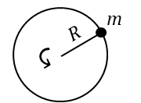I. *ac* is constant and zero IV. *at* is constant and zero

II. *ac* is constant and nonzero V. *at* is constant and nonzero

III. *ac* is continuously changing VI. *at* is continuously changing

i. If ** = 0, then – *as a result of m going in a circular path* – *m* will experience Choice ____.

ii. If ** = 0, then – *as a result of m NOT changing its linear speed* – *m* will experience Choice ____.

iii. If ** ≠ 0 but constant, then – *as a result of m going in a circular path* – *m* will experience Choice ____.

iv. If ** ≠ 0 but constant, then – *as a result of m changing its linear speed* – *m* will experience Choice ____.

v. If ** ≠ 0 and changing, then – *as a result of m going in a circular path* – *m* will experience Choice ____.

vi. If ** ≠ 0 and changing, then – *as a result of m changing its linear speed* – *m* will experience Choice ____.