**APPC, Mechanics: Unit  HW 2** Name: ________________________________________

Hr: ____ Due at beg of hr on: ______________

U, HW2, P1

Reference Videos: (1) “Torque”

(2) “Torque and the Cross Product (Part II)”

YouTube, lasseviren1, ROTATIONAL MOTION playlist

A. Newton’s 1st Law of Rotation: An object will remain __________________________ or will continue with ________________ _________________ ______________ unless acted upon by a ______ ___________________ _____________.

B. Write the definition for **torque**.

C. Write ONE equation for finding the *magnitude* of torque.

D. Write TWO equations that show the *vector* nature of torque.

E. $\vec{r}$ is a vector that starts at the _________ of rotation and extends to the point where the ____________ is applied. One common term for $\vec{r}$ is the ____________ _______. When using the **cross product** on $\vec{r}$ and $\vec{F}$, these two vectors must be (mentally, anyway) oriented _________-____-_________. This is different from when you are simply adding vectors (like you did in first-year Physics), where you learned that vectors to be added must be oriented _________-____-_________. What the narrator writes as *r*⟘ is termed the ____________________ ____________ _______. The imaginary line that extends infinitely in the exact direction that the force points is often called the _________ ____ ____________ of the force. If this imaginary line goes through the _________, there is zero ________________.

F. We learned a while ago that the *dot product* is also called the *scalar product*. To review: Why is that?

G. As a follow-up to your Part F answer... Why is the *cross product* also called the *vector product*?

H. CIRCLE whether each operation is commutative or not. If an operation IS commutative, then also write one example, using numbers or variables, whichever you prefer. Otherwise, no example is needed.

i. addition COMMUTATIVE NOT COMMUTATIVE Example, if commutative:

ii. subtraction COMMUTATIVE NOT COMMUTATIVE Example, if commutative:

iii. division COMMUTATIVE NOT COMMUTATIVE Example, if commutative:

iv. multiplication COMMUTATIVE NOT COMMUTATIVE Example, if commutative:

v. dot product COMMUTATIVE NOT COMMUTATIVE Example, if commutative:

vi. cross product COMMUTATIVE NOT COMMUTATIVE Example, if commutative:

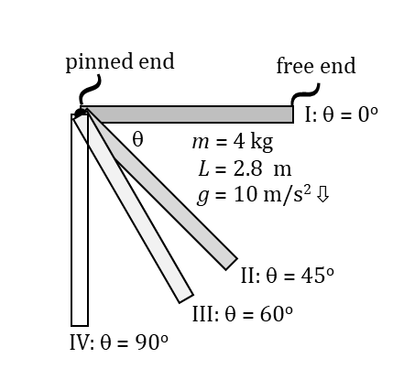U, HW2, P2

Reference Videos: (1) “Torque and the Cross Product (Part II)”

(2) “Torque and the Cross Product (Part III)”

YouTube, lasseviren1, ROTATIONAL MOTION playlist

A. Torque is the rotational analog of ______________.

B. The figure shows a rod of mass 4 kg and length 2.8 m that is pinned to the wall

at its left end; its right end is free to move. The rod is released from rest in

Position I and the right end begins to fall; it reaches Positions II, III, and IV in succession. (If you

know *sin* and *cos* values for simple right triangles, you will NOT need a calculator for this exercise.)

i. In EACH of the four depictions in the figure, draw a dot showing where the rod’s center of mass is.

In the Position I depiction ONLY, label this dot “com”. (Ha! “dot-com”... Get it? 🙂)

ii. The net torque on the rod is generated by the force of the rod’s weight. This weight is

a constant for all four depictions. What are the magnitude and direction of this force?

iii. Torque also depends on the effective lever arm, which the narrator denotes as *r*⟘ . What

is the effective lever arm for each rod configuration? (There is no need to show work.)

*r*⟘ for I = *r*⟘ for II = *r*⟘ for III = *r*⟘ for IV =

iv. Use your Parts Bii and Biii answers to calculate the torque for each depiction. Show your work.

** for I = ** for III =

** for II = ** for IV =

v. Look back at your Part A answer. To review... According to Newton’s 2nd law, the larger THAT

quantity is (for a given mass), the larger will be the mass’s ___________________________.

vi. Now, follow the logic here... Torque, we said, is the rotational analog of your Part A answer. Therefore – according to the *rotational* version of Newton’s 2nd law (more on this later) – the larger the torque is (for a given object), the larger will be the object’s *rotational analog to your Part Bv answer*, i.e., the larger will be the object’s ____________________ ___________________________. And we see, from your Part Biv answers, that your previous answer will be maximized at Position _____.

vii. At which Position will the rod’s angular speed be maximized? (CIRCLE) I II III IV

viii. Explain why your last answer in Part Bvi and your Part Bviii answer are NOT the same.

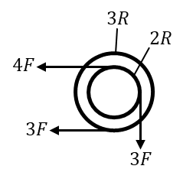C. As shown in the second video, determine the net torque (direction – i.e., CW or CCW – and magnitude).

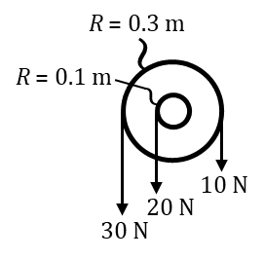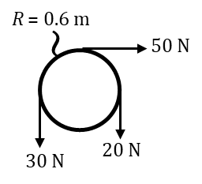

i. ii. iii.

U, HW2, P3

Reference Video: “Static Equilibrium Problems in Mechanics”

YouTube, lasseviren1, ROTATIONAL MOTION playlist

A. The conditions for static equilibrium (in mechanics) are: no ________________________ (i.e., ___ = ZERO) AND no _________________ ________________________ (i.e., ___ = ZERO). From Newton’s 2nd laws of (1) translation and (2) rotation, this means that, in the first case, _______ = ZERO; in the second case, _______ = ZERO.

B. The objects below are subject to ONLY the forces shown. For each case, determine the net force on the object AND the net torque about the object’s center of mass, which is labeled with a • . Finally, circle whether the object is in a state of static equilibrium or not.

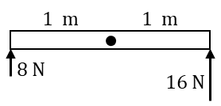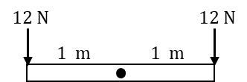 i. iii.

*Fnet* = *Fnet* =

*net* = *net* =

In static equilibrium? YES NO In static equilibrium? YES NO

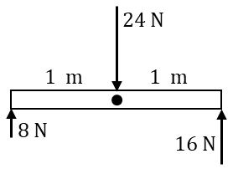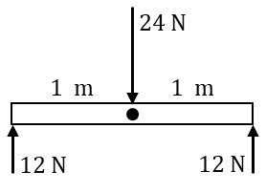

ii. iv.

*Fnet* = *Fnet* =

*net* = *net* =

In static equilibrium? YES NO In static equilibrium? YES NO

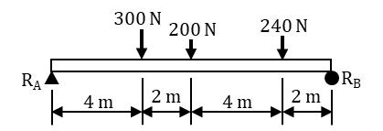

Refer to the figure at right to answer the following questions. Your goal is to

determine the two support reactions, RA and RB. Ignore the beam’s weight.

C. Into the figure, draw two upward-pointing vectors, one at each end.

These vectors represent the reactions (i.e., the forces) RA and RB.

D. For static equilibrium, *Fnet* must equal zero. Here, that means that

“the sum-of-the-ups” must equal “the sum-of-the-downs”. Write an equation

expressing this. (HINT: Your equation will have THREE “+” signs in it.)

E. You can simplify one side of your Part D answer. Do that, and rewrite the equation.

You cannot solve your Part E equation because it has two unknowns. So we need another equation, this one satisfying the other condition of equilibrium, i.e., that *net* must also equal zero. To do this, we choose some point (ANY point) of rotation and write the equation: “CW-torques = CCW-torques”.

F. Let’s choose the left end of the beam as the rotation point, about which you will take the torques.

Now, YOU write the torque equation, as described above. (HINT:

Your equation will have ONE unknown and TWO “+” signs in it.)

G. Solve your Part F answer for the unknown.

H. Substitute your Part G answer into your Part E answer to find the other unknown. You did it! 🙂

I. Why is it convenient to choose your rotation point along the line of action of one of your unknowns?

U, HW2, P4

Reference Videos: (1) “Static Equilibrium Problems in Mechanics”

(2) “Static Equilibrium Problems (Part II)”

YouTube, lasseviren1, ROTATIONAL MOTION playlist

A. Use the technique you practiced in HW2, P3, Parts C-H to determine the two support reactions for each of the figures below. As before, consider the weight of the beam as negligible.

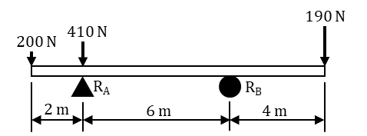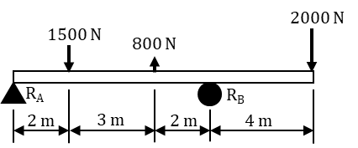

i. ii.

B. One of the four reactions you obtained in Part A should have stood out from the other three. State how that reaction stood out as being different AND explain the physical meaning of this *different-ness*.

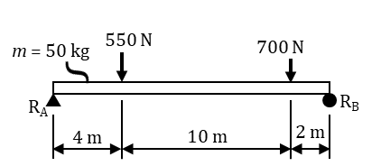If the weight of the beam is NOT negligible, then you must consider ALL of that weight to act as an additional point load at the beam’s center of mass. In solving the following problem, use *g* = 10 m/s2.

C. Into the figure at right, draw in a force vector that represents the beam’s weight. Draw the vector in the correct location and point it in the correct direction. Label the vector with its numerical

magnitude. Finally, add any necessary dimensions (using two-

headed arrows of specified lengths) to show the precise location of your force vector.

D. Now, taking into account your Part C answer, determine the two support reactions for the beam above.

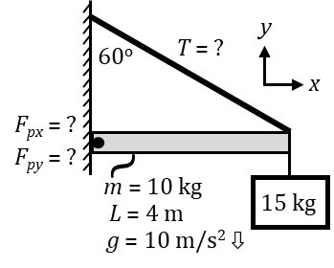E. Use the technique demonstrated in the second video to determine the three

unknown quantities specified in the figure.

U, HW2, P5

Reference Videos: (1) “Moment of Inertia or Rotational Inertia”

YouTube, lasseviren1, ROTATIONAL MOTION playlist

(2) “Rotational Inertia for a Long Slender Rod” YouTube, lasseviren1

A. Write the general form of the equation for finding the

**moment of inertia** of a collection of point masses.

B. The narrator sometimes refers to the moment of inertia (or the **rotational inertia**) as ___________________ _______________________________. From your Part A answer, you see that (1) the proper SI unit for moment of inertia is __________ and that (2) the quantity that is MORE influential in determining the value of a certain configuration’s moment of inertia is: (CIRCLE) MASS DISTANCE FROM THE AXIS

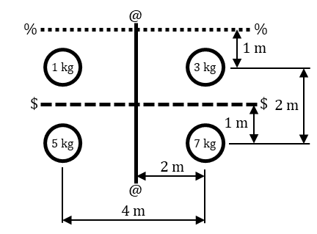C. Use your Part A answer to determine the rotational inertia (with units)

of the following collections of mass about each of the axes shown.

i. *I*axis $-$ =

ii. *I*axis %-% =

iii. *I*axis @-@ =

D. Following the pattern from your Part A answer...If we had a VERY tiny mass *dm* that was a

distance *r* away from a rotational axis, it would have a VERY tiny moment of inertia *dI*, i.e.,

$dI=dm r^{2}$, which we could rewrite equally well as... $dI=r^{2} dm$

But if we had a BUNCH of tiny *dm* masses, each a unique distance *r* away from the axis, and we wanted the TOTAL moment of inertia *I* from all of those *dm* pieces, then the calculus expression for *I* would be written...how?

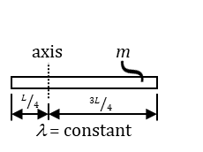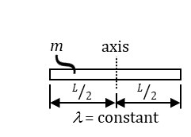In the video, the narrator derives the moment of inertia for a rod of uniform **linear mass density** ** about one axis through the midpoint. (See the figure at right.) As you saw in the video, the answer comes out to be $I=\frac{1}{12}mL^{2}$. Here, we derive *I* for the same rod, but about the axis shown in the second figure, just below the first.

E. How do you expect your *I* about the new axis to compare to the *I* about the mid-point? Explain briefly. (HINT: Refer back to the last part of your Part B answer.)

F. ** is the linear mass density, i.e., ** Since ** is simply a ratio,

it is perfectly valid to write ** Solve this last expression for *dm*.

G. Substitute your Part F answer into your Part D answer. Considering the axis to be at *r* = 0, your integration limits can be taken to be from *r* = –¼ *L* to *r* = +¾ *L*. Be sure to include these limits in your answer.

H. Carry out the integration of your Part G answer and simplify to obtain the *I* about the new axis. DON’T forget to substitute back in...the first equation given in Part F.