Acid Rain Experiment

Introduction

Acid rain is a problem that has been affecting the world for several years. This ecological issue not only harms our lakes and streams but also kills trees and destroys statues. Acid rain results when either sulfur dioxide (SO₂) or nitrogen oxides (NO_{x}) dissolve in water. Coal and oil-burning power plants generate approximately two-thirds of the sulfur dioxide pollution, while vehicles with internal combustion engines (e.g. automobiles) generate approximately two-thirds of the nitrogen oxide pollution.

Normal precipitation is slightly acidic because the normal carbon dioxide in the air dissolves in water to make a slightly acidic solution with a pH of about 6.5. Some rain in the Northeastern United States has been found to be with a pH as low as 3.5.

Collecting rainwater regularly to measure acidity can provide important data from widespread sites across the country. Trends and variations can be noted, and changes over time can indicate possible problems to be solved. Through this lab we will be testing rain water at various points throughout the country and observe different variable regarding acid rain.

Materials

For each time it rains, you will need:

Several plastic containers large enough to collect at least 1 Liter of rain
pH indicator solutions (red cabbage juice, grape juice, beet juice, red onion juice)
wide-range pH paper
filter paper and funnel
four or five test tubes
stirring rod

Be sure the that plastic containers and the stirring rod are very clean and rinsed. If an soap or other contaminants are in the containers, the pH results will be incorrect.

Safety

None of the procedures in this experiment are abnormally dangerous.

Procedure

Part I - Collecting the Rain Water

After your plastic containers are washed and rinsed well, place them in the open rain. Immediately after the rain stops, pour the rainwater through filter paper and collect it in another clean plastic container. Do not let the water sit for an extended period of time for this will alter the pH of the water.
Dip a clean stirring rod into the rainwater and then touch it to a piece of wide-range pH indicator paper. Make a note of this initial pH in your data table.

Pure water has a neutral pH which is close to 7. Normal rainwater has a pH slightly less than 7, around 6.5, because of gases it absorbs from the air. As was mentioned earlier, in the Northeaster United States, rain has been found with pH's as low as 3.5. Keep in mind at this point that pH is measured on a logarithmic scale meaning that something with a pH of 6 is 10 times more acidic than something with a pH of 7.

Part II-Preparing the indicator solutions

This part only needs to be completed the first time it rains.

In order to test the rain water with more than one indicator, we will make some natural indicator solutions.

These solutions will be based on the chemical family of anthocyanins. These chemicals are responsible for many different colorations in nature. They affect the red and purplish colors of autumn leaves, the red and purplish colors of summer vegetables (red cabbages, red lettuce, red plum tree), flowers (roses, hydrangeas, geraniums, bachelor buttons, dark pansies), fruit (cherries, red apples, grapes, tomato, blackberry, blueberry, plum), roots (beets, radishes), bulbs (red onions), and petioles (rubarb). Anthocyanins are found within the cells of these plants. If the cells in a leaf are acidic, the anthocyanins are a bright red color, but if they are less acidic the leaves are a deeper purple. Since the color of the anthocyanins is affected by acidity, it can be used as an indicator of the strength of an acid.

A pH scale is given on the following page for the different indicator solutions we will be using. This scale quantifies the acidity of a substance based on the color the indicator turns. For example, in a neutral solution, red cabbage is a purple color, but when the solution turns acidic, the indicator turns a red color. Similarly, when the solution turns basic, the indicator turns a yellow color.

Natural indicator solutions

Using a knife and cutting board, carefully dice a quarter head of red cabbage, several large onions, or several medium beets. Boil for ten minutes in a pan or beaker containing 1000 ml of water. Allow the mixture to cool and then pour the contents through a strainer or filter paper and collect in a beaker. The extract should appear a dark purple, the color of anthocyanin at pH 7. Grape juice can simply be used by itself. Most plants that appear red or purple contain anthocyanin and can be made into indicators. The four we are preparing are considered quality indicators.

Part III - Testing the rain with indicator solutions

This part only needs to be completed one time it rains.

Divide the rain sample into four or five portions to test with the indicator solutions. In each of the portions place about 20 mL of a different indicator solution. The following scales can be used for the suggested indicator solutions.

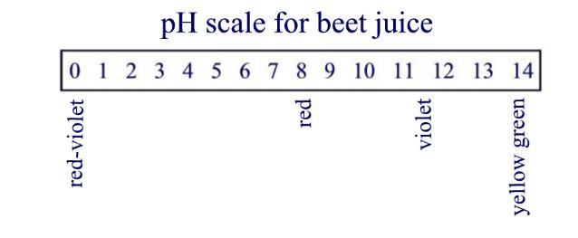 | 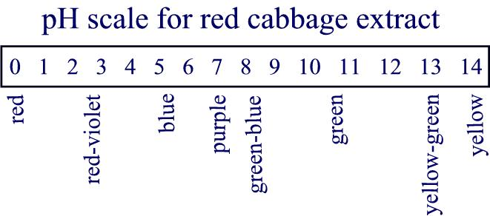
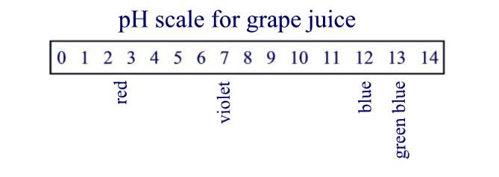 | 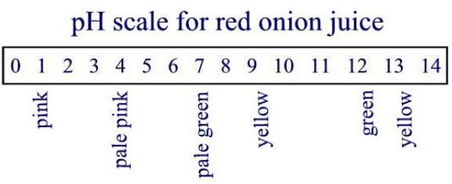

The Chemistry behind it all

Acid rain results when either sulfur dioxide (SO₂) or nitrogen oxides (NO_{x}) dissolve in water. The picture below summarizes the entire process of acid rain production. The explanation following the picture describes the chemistry behind the process.

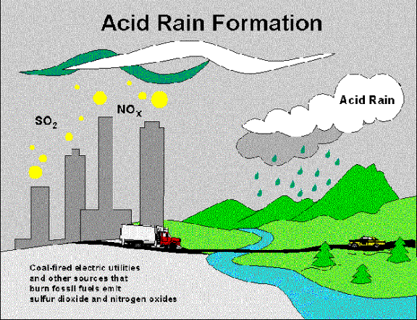
Sulfur is one of the elements commonly found in coal. When coal is burned to generate electricity or to warm a building, the sulfur is oxidized and becomes sulfur dioxide, a gas with a strong suffocating odor:

S₈ (s) + 8 O₂ (g) 8 SO₂ (g)

As sulfur dioxide dissolves in water vapor in clouds, sulfurous acid forms:

SO₂ (g) + H₂O (l) 2 H₂SO₄ (aq)

Sulfuric and sulfurous acid are highly soluble in water and fall to the earth in rain or snow.

Internal combustion engines develop extremely high pressures and temperatures in which atmospheric nitrogen and oxygen combine to form a variety of nitrogen oxides. Nitrogen dioxide is one of these chemicals that is released into the environment. As the nitrogen dioxide dissolves in the water droplets, nitric (HNO₃) and nitrous acid (HNO₂) are formed:

2 NO₂ (g) +H₂O (l) HNO₃ (aq) + HNO₂ (aq)

Both of these acids harm or even destroy different parts of our environment. The acid rain tears toxic metals from the soil depositing them in our drinking water. Waxy cuticles on leaves are damaged, and the eggs of fish and other aquatic live cannot survive. And it all relates back to the chemistry of the industrial age.

