Chemistry: Balancing Equations Activity Name _________________________

Directions: Listen to the instructions of your teacher and follow the example below to help you
understand how to complete this activity.

____ CO + ____ O₂ ____CO₂
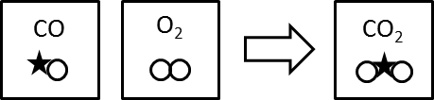

Use the pieces provided to balance each of the following equations. Then fill in the table.

How many atoms of
each type participate
in the reaction?
Equation | C | H | O
____ CH₄ + ____ O₂ ____ H₂O + ____CO₂
____ H₂ + ____ O₂ ____ H₂O

____ H₂ + ____ O₂ ____ H₂O₂

____ CH₄ + ____ O₂ ____ CH₃OH

____ C₆H₁₂O₆ + ____ O₂ ____ H₂O + ____CO₂

____ C₃H₈ + ____ O₂ ____ H₂O + ____CO₂

____ CO₂ + ____ H₂ ____ H₂CO + ____O₂

My rules for balancing C,H,O compounds:  Step 1) balance carbon first  Step 2) balance hydrogen next  Step 3) balance oxygen last | How to balance a chemical equation:  1) polyatomic ions first  2) even / odd (make all odd even)  3) single elements last  4) ⁵/₂ (O₂) = 5 oxygen and then double equation

