Shapes of Molecules & Bond Angles

Bonds on Central Atom | Lone Pairs on Central Atom | 3-D Shape of Molecule | Name of Shape | Bond Angle | Structural Formula
1 | Not Applicable |  | Linear | 180° | Double and triple bonds are linear!
2 | 0 | 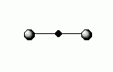 | Linear | 180° | Outside atoms can have any number of lone pairs  (This applies to all atoms below & above also.)
3 | 0 |  | Trigonal Planar | 120°
4 | 0 | 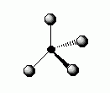 | Tetrahedral | 109.5°
3 | 1 | 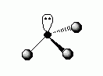 | Trigonal Pyramidal | 107°
2 | 2 |  | Bent | 105°
5 | 0 | 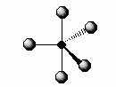 | Trigonal Bipyramidal | 120° and 90°
6 | 0 | 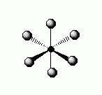 | Octahedral | 90°

