**Homework Questions: Section 6** Name _________________________________

1. Why is it NECESSARY to connect a voltmeter in parallel with a circuit component?

2. Why is it NOT a good idea to connect an ammeter in parallel with a circuit component?

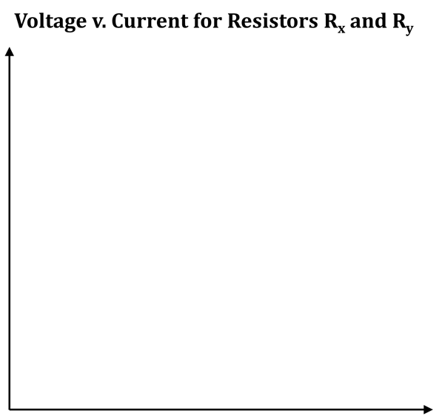3. Using your data from Tables 6.10b and 6.10c, plot a graph of voltage versus current for Rx and Ry, on the same set of axes. Place voltage on the vertical

axis and current on the horizontal axis. Label each

axis, and put the correct unit in parentheses

next to each label. Put numbered “tick-

marks” along each axis to show

the scale of the graph.

a. In what MAJOR way do the two lines differ?

b. What QUANTITY of the resistors does your

answer to Q2a define?

c. On the graph, what would the line look like

for a third type of resistor (call it Rz)

that has a HIGHER resistance than

either Rx or Ry?

4. A circuit consists of a battery of three cells, along with bulbs in series. Bulb A (which is closer to the + battery terminal) is receiving energy at the rate of 15 W. Bulb B (which is closer to the – battery terminal) is receiving energy at the rate of 40 W.

a. To the right, draw a schematic diagram; label bulbs A and B.

b. For the following, decide if each statement applies

to bulb A, bulb B, or neither.

i. _____________ the light from the bulb is brighter

ii. _____________ the current through the bulb is greater

iii. _____________ the resistance of the bulb is larger

c. On your schematic, draw arrowtails and starbursts. NOTE: These should support your answers to Q4b.

5. You have two circuits, each with two batteries. In circuit (S), a round bulb and a long bulb are in series. In circuit (P), a round bulb and a long bulb are in parallel.

a. To the right, draw schematics of both circuits.

b. For each of the following, decide if the statement

applies to circuit S or circuit P.

i. ____ The round bulb is converting energy to heat

and light at a greater rate than the long bulb.

ii. ____ The long bulb is converting energy to heat SCHEMATIC OF SCHEMATIC OF

and light at a greater rate than the round bulb. CIRCUIT S CIRCUIT P

iii. ____ The battery is transferring energy at a greater rate.

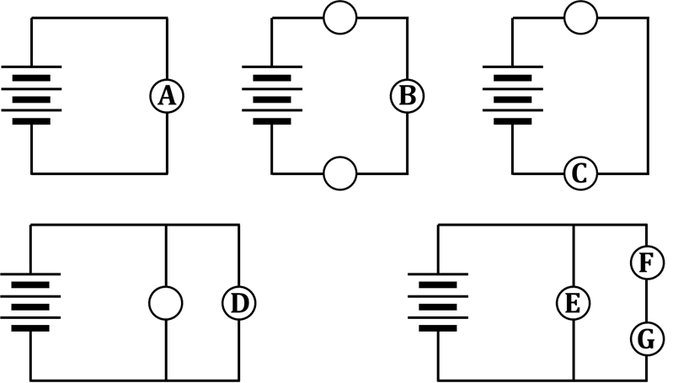

6. In the circuits shown, all bulbs are identical

(even if they don’t have a letter in them).

Circle the correct answers below.

a. Between A and D… A is brighter D is brighter they have the same brightness

b. Between C and E… C is brighter E is brighter they have the same brightness

c. Between B and C… B is brighter C is brighter they have the same brightness

d. Between C and F… C is brighter F is brighter they have the same brightness

e. Between D and G… D is brighter G is brighter they have the same brightness

f. Between B and G… B is brighter G is brighter they have the same brightness

g. Between D and E… D is brighter E is brighter they have the same brightness

7. An old string of Christmas lights has 20 bulbs connected in series. Each bulb is labeled 1.5 W.

a. Calculate the rate at which energy is being

supplied when all 20 bulbs are lit.

b. Describe the energy transformations that are

occurring in the circuit when the bulbs are lit.

c. Describe what happens to the rate of energy transfer if the 15th bulb in the string burns out.

8. This question relates to how riding a bicycle is, in some ways, analogous to what occurs in an electrical circuit. To answer this question, you need to imagine two things:

(1) YOU, riding a bike

(2) a circuit containing batteries and light bulbs

a. What is the SOURCE of energy that makes things move in… …riding a bike?

…an electrical circuit?

b. What is the DESTINATION of the energy from Q6a in… …riding a bike?

(i.e., Where do WE WANT it to go?)

…an electrical circuit?

c. What is the THING (or THINGS) that enable(s) the

energy transfer to occur in… …riding a bike?

(i.e., this helps the energy get from one place to another)

…an electrical circuit?

d. Circle the correct choice here, which relates to your answer from Q6c:

During the energy transfer process, the thing (or things) is/are… USED UP RECYCLED/REUSED

9. Complete the diagram below by putting the correct pressure-difference values into each voltmeter. Note that the voltmeter placed across the battery has the correct readout of 4.5 V.

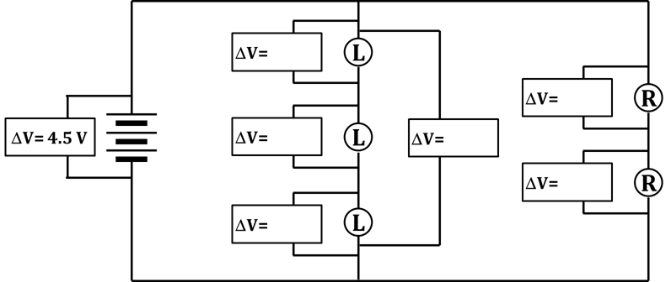

10. You need to design a 1200-watt hair dryer for use in American homes. For any question below that asks WHICH VARIABLE?, include the VARIABLE SYMBOL, the NAME of the quantity, and the UNIT.

a. Use the electrical power equation **P = I V** to help you answer the following few questions.

i. The value for WHICH VARIABLE is given in the problem statement?

ii. WHICH VARIABLE will the homes’ electrical systems provide?

iii. You were told the numerical value for your answer to Q10aii way back in

your Section 5 HW, Q3. Report that numerical value – and unit – here.

iv. Based on your answers to Q10ai and Q10aii, you should now

be able to calculate WHICH VARIABLE for the hair dryer?

v. Now, calculate the value, with unit, for the

quantity you mentioned in Q10aiv.

b. i. Recall that Ohm’s law is the equation **V = I R** At this point in the process – and

with the help of Ohm’s law – you can calculate WHICH VARIABLE for the hair dryer?

ii. Now, calculate the value, with unit, for the

quantity you mentioned in Q10bi.

c. Summarize your answers to the various parts of Q10 by filling in the blanks:

“To design the specified hair dryer, I know that the ___________________ consumed will be 1200 watts. Since the ___________________ in the electrical outlets of American homes is always ___________________, I can use those two numbers to calculate the ___________________ in the hair dryer to be exactly ___________________. Then, from Ohm’s law, I am further able to calculate that the ___________________ of the hair dryer should be exactly ___________________. So all I need to do is find a material or a device with that amount of ___________________ and put that into the hair dryer’s circuit.”

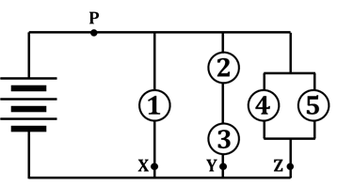11. Answer the questions below, based on the circuit shown.

a. Where is the current the greatest: through point X, Y, or Z?

b. Where is the current the least: through point X, Y, or Z?

c. If a shorting wire is placed around bulb 5, what will be

the effect on the circuit?

d. Besides bulb 5, placing a shorting wire around which other bulb(s)

will have the same effect as your answer to Q11c?

e. If another bulb is inserted at point P, what will be the effect on the circuit?

f. Explain your answer to Q11e; WHY IS IT that that’s what happens?