“Elements, Compounds, and Mixtures”

**Description**: This slide shows the molecular composition of an element, a compound, and two mixtures.

# Basic Concepts

* All samples of a substance have the same molecular composition and intensive properties and are homogeneous.
* Elements and compounds are substances; mixtures are not.
* The elements making up a compound combine in fixed ratios.
* Mixtures can be separated by physical methods.
* Mixtures that have a uniform composition throughout are homogeneous; those that have parts with different compositions are heterogeneous.

# Teaching Suggestions

Use this transparency to help students visualize the molecular composition of elements, compounds, and mixtures and to review the definitions of these terms. Make sure students understand the difference between the terms *matter* and *substance*. Remind students that elements and compounds are always homogeneous, while mixtures can be either homogeneous or heterogeneous.

**Questions**:

1. Which of the bottles pictured above contain(s) matter? Which contain(s) a single substance? Explain your answers.
2. How many elements are present in each molecule of water shown in bottle (b)? What is the relative number of atoms of each element in a water molecule?
3. As you know, ice is frozen water. In other words, ice and water are the same substance, in different phases. What would you expect the ratio of hydrogen atoms to oxygen atoms to be in a molecule of ice? Explain your reasoning.
4. Bottle (c) and bottle (d) both contain mixtures. How are these mixtures similar? How are they different?
5. Suppose you find an unlabeled bottle containing a clear liquid. Can you tell by looking at it whether the material is a compound or a mixture? Explain your answer.
6. How can you prove that a sample of sea water is a mixture?
7. Classify the following items as elements, compounds or mixtures; rice pudding, copper, carbon dioxide, air, milk, magnesium chloride, granite, mercury, and maple syrup.
8. A chocolate-chip cookie with more chips in one part of the cookie than another can be used to demonstrate a heterogeneous mixture. Name two other materials that can be classified as heterogeneous mixtures. Explain your reasoning.

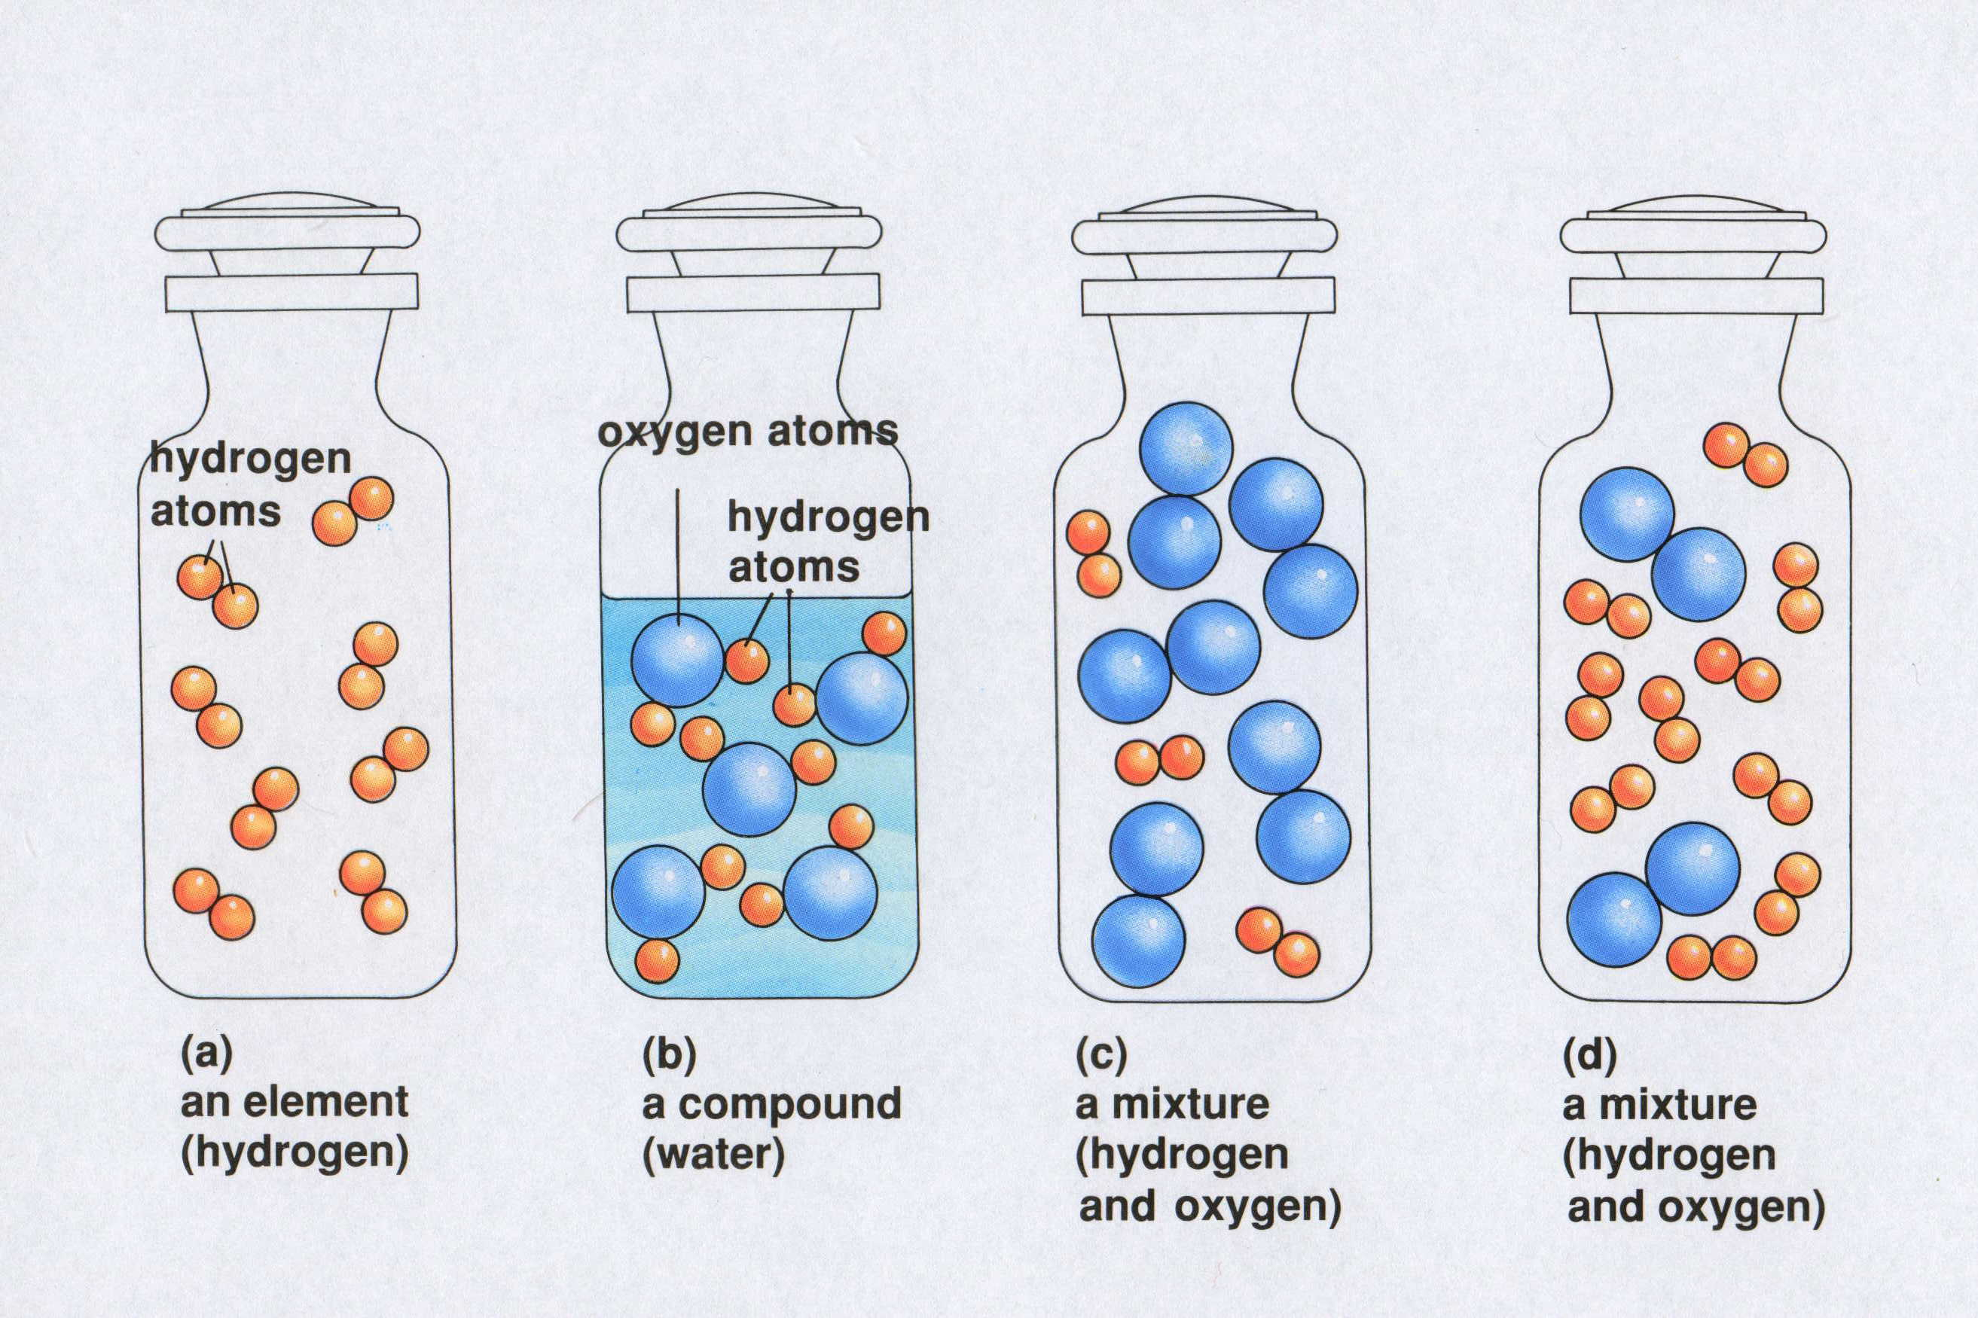

Two Ways of Viewing Density

# Description

This slide illustrates mass / volume (density) relationships for gold and aluminum.

# Basic Concepts

* Density is an intensive property, that it, it does not depend on the size of the sample.
* The density of an object can be calculated using the following formula: density = mass / volume.
* The density of a substance changes with changes in temperature.

# Teaching Suggestions

Use this slide to review the definition of density. Remind students that density is an intensive property. Review the equation for calculating the density of a sample.

Point out that density describes the relationship between the mass and the volume of a sample.

To make this concept more concrete, use numbers with the concept of density. In the case of aluminum and gold, there is less mass in 1 cm3 of aluminum (2.7 grams) than in 1 cm3 of gold (19.3 grams). Put another way, 1 gram of aluminum occupies a larger volume (0.37 cm3) than 1 gram of gold (0.05 cm3).

# Questions

1. What does diagram (A) show about density?
2. What does diagram (B) show about density?
3. Would a knowledge of density be useful in
   1. Choosing a material with which to construct a 10-kilogram barbell?
   2. Selecting a head of lettuce that will give you the most lettuce for your money if lettuce sells for 99 cents a head?
   3. Predicting whether an object would float or sink in water?

For each, explain why or why not.

1. Suppose a 20-gram cube of aluminum were cut into four equal parts. How would the density of one part be related to the density of the whole cube?
2. Metals expand when heated. If gold is heated, what will happen to its density? Explain.
3. The density of ice is 0.9 g/cm3, and the density of water is 1.0 g/cm3. Suppose a glass containing ice is filled with water so the ice is even with the rim of the glass. As the ice melts, would you expect any water to spill out of the glass? Why or why not?

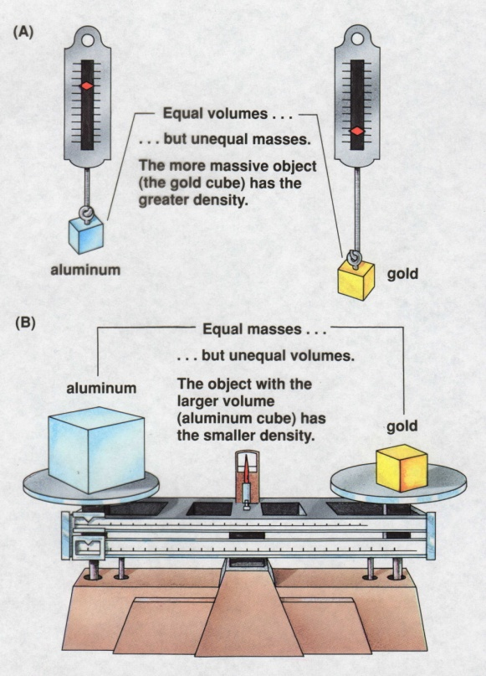

An Investigation of the Process of Burning

# Description

This slide shows an experiment similar to the work done by Antoine Lavoisier in 1778, which demonstrated that mass is conserved in chemical reactions.

# Basic Concepts

* Mass is neither created nor destroyed when substances react with one another (the law of conservation of mass)
* Gases, such as air, are matter and thus have mass and volume.

# Teaching Suggestion

Use this slide to teach the law of conservation of mass. Explain that, at the time Lavoisier was investigating the process of burning, scientists thought that a change in mass could occur during a chemical reaction. They observed that when some materials were burned, the substance produced had a larger mass that the starting material. Lavoisier, however, postulated that the extra mass came from the air. When he excluded outside air from the reaction, the total mass did not change.

# Questions

1. In diagram (A), how does the product of the reaction differ from the original magnesium strip? How are they similar?
2. List three possible explanations that could account for the fact that the white powder has more mass than the magnesium strip in diagram (A). Then, for each of your explanations, decide whether the experiment shown in diagram (B) supports or refutes the explanation. Explain your reasoning.
3. Why is there no change in total mass when magnesium is burned in a closed flask?
4. In diagram (B), if you were to determine the mass of the white powder alone, how would it compare to the mass of the magnesium strip? How would the mass of the white powder in diagram (B) compare with the mass of white powder in (A)? Explain your answers.
5. What would you expect to happen if the stopper were removed from the closed flask containing the white powder in diagram (B)? Explain your answer.
6. Suppose that a person dropped 8.4 grams of baking soda into a beaker containing 150 g of vinegar. Bubbling occurred, releasing a gas. When the bubbling stopped, the mass of the material in the beaker was 154 g. What was the mass of the gas produced in this reaction?
7. 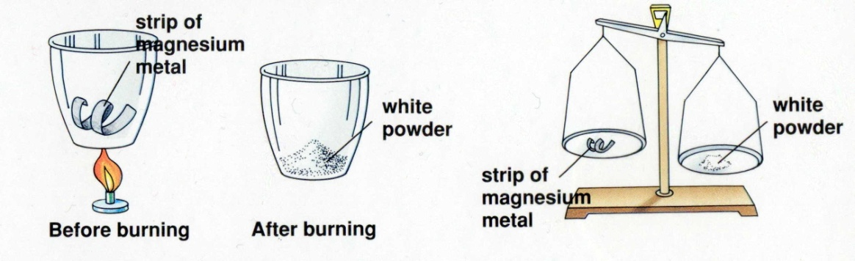A friend tells you that mass is not conserved when a candle burns, because the candle gets smaller and smaller. Explain to your friend what must really happen when a candle burns.

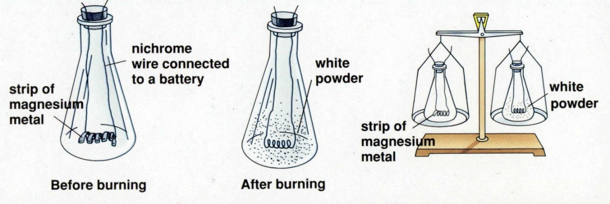Cathode Rays

This slide demonstrates the use of a cathode ray tube in J.J. Thomson’s discovery of the electron.

# Basic Concepts

* In a cathode ray tube, negative particles or radiation are emitted from the cathode and attracted to the anode.
* Electrons are fundamental particles present in the atoms of all elements.

# Teaching Suggestions

Use this slide to familiarize students with the experiments that led to the discovery of the electron. Discuss how Thomson was able to conclude from his observations that electrons are fundamental particles found within all atoms. Explain that most of the air was removed from the tube and that a high voltage was applied, producing negatively charged terminal (cathode) and a positively charged terminal (anode). Review that negatively charged particles are attracted to positively charged objects.

# Questions

1. When William Crookes conducted the experiments shown in diagram (A), he noted that a shadow appeared on the end of the tube. What did this shadow tell him about cathode rays? Explain.
2. To find out more about the nature of cathode rays, J.J. Thomson placed a disk with a slit in it in front of the cathode. What happened to the cathode rays?
3. The other modifications J.J. Thomson made to the tube was to install positively and negatively charged plates, as shown in diagram (B). To his surprise, the beam of rays was bent toward the positively charged plate. What did this observation tell Thomson about the nature of cathode rays?
4. What would have happened if the rays had been positively charged particles? What if the rays had no electrical charge (for example, if they were light rays)?
5. Thomson repeated his experiments using different materials for the electrodes and a variety of gases in the cathode ray tube. In all cases, the cathode ray particles behaved in the same manner. What did these results tell Thomson? Why was it important to conduct these additional experiments?

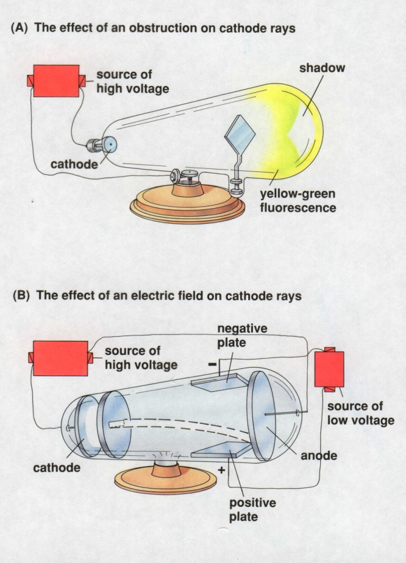Rutherford’s Experiment

# Description

This slide illustrates Ernest Rutherford’s experiment with alpha particles and gold foil and his interpretation of the results.

# Basic Concepts

* When charged particles are directed at high speed toward a metal foil target, most pass through with little or no deflection, but some particles are deflected at large angles.
* Solids are composed of atoms that are closely packed. The atoms themselves are mostly empty space.
* All atoms contain a relatively small, massive, positively charged nucleus. The nucleus is surrounded by negatively charged electrons of low mass that occupy a relatively large volume.

# Teaching Suggestions

Use this slide to describe and explain Rutherford’s experiment. Rutherford designed the apparatus shown in figure (A) to study the scattering of alpha particles by gold. Students may have difficult with the concepts in this experiment because they lack the necessary physics background. To help students understand how it was determined that the nucleus is relatively massive, use questions 3 and 4 to explain the concept of inertia.

Explain that the electrostatic force is directly proportional to the quantity of electric charge involved. A greater charge exerts a greater force. (Try comparing the electrostatic force to the force of gravity, which is greater near a massive object like the sun, but smaller near an object of lesser mass, such as the moon.) The force exerted on an alpha particle by a concentrated nucleus would be much greater that the force exerted on an alpha particle by a single proton. Hence, larger deflections will result from a dense nucleus than from an atom with diffuse positive charges.

Point out that Rutherford used physics to calculate how small the nucleus would have to be produce the large-angle deflections observed. He calculated that the maximum possible size of the nucleus is about 1/10,000 the diameter of the atom. Rutherford concluded that the atom is mostly space.

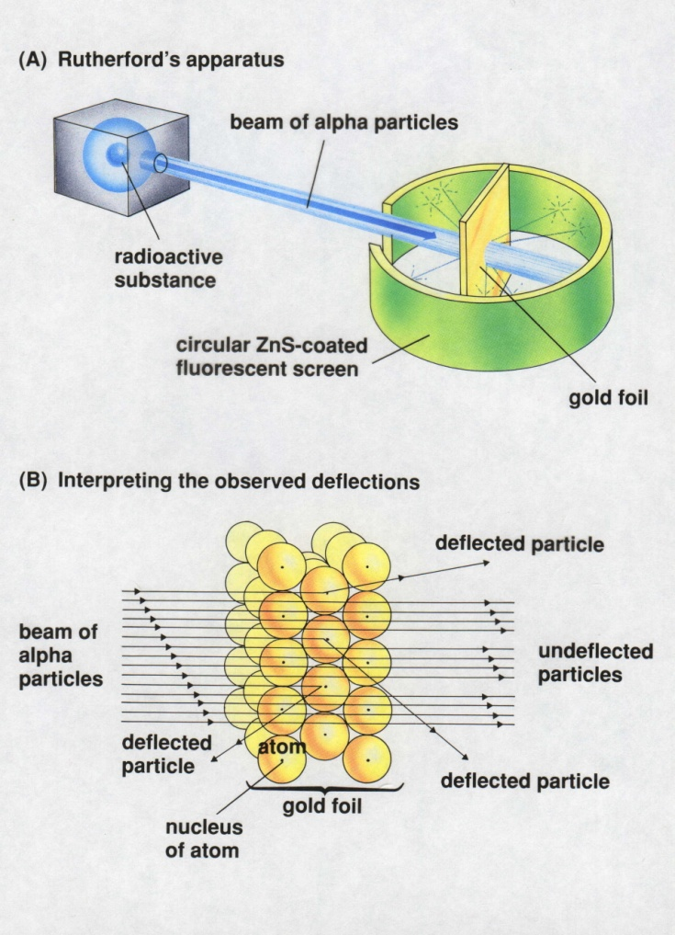Rutherford’s Experiment

# Description

This slide illustrates Ernest Rutherford’s experiment with alpha particles and gold foil and his interpretation of the results.

# Questions

1. If gold atoms were solid spheres stacked together with no space between them, what would you expect would happen to particles shot at them? Explain your reasoning.
2. When Ernest Rutherford performed the experiment shown in diagram (A) he observed that most of the alpha particles passed straight through the gold foil. He also noted that the gold foil did not appear to be affected. How can these two observations be explained?
3. Can you explain why Rutherford concluded that the mass of the f\gold nucleus must be much greater than the mass of an alpha particle? (Hint: Imagine one marble striking another marble at high speed. Compare this with a marble striking a bowling ball.)
4. Do you think that, in Rutherford’s experiment, the electrons in the gold atoms would deflect the alpha particles significantly? Why or why not? (Hint: The mass of an electron is extremely small.)
5. Rutherford experimented with many kinds of metal foil as the target. The results were always similar. Why was it important to do this?
6. A friend tries to convince you that gold atoms are solid because gold feels solid. Your friend also argues that, because the negatively charged electrons are attracted to the positively charged nucleus, the electrons should collapse into the nucleus. How would you respond?
7. As you know, like charges repel each other. Yet, Rutherford determined that the nucleus contains all of an atom’s positive charges. Invent a theory to explain how all the positive charges can be contained in such a small area without repelling each other. Be creative!

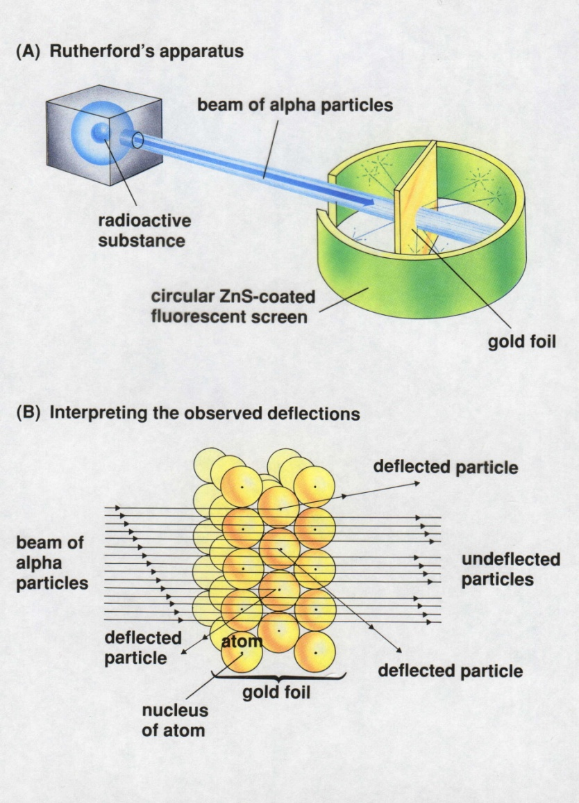Models of the Atom

**Description**: This slide shows he evolution of the concept of the atom from John Dalton to the present.

# Basic Concepts

* The model of the atom changed over time as more and more evidence about its structure became available.
* A scientific model differs from a replica (physical model) because it represents a phenomenon that cannot be observed directly.

# Teaching Suggestions

Use this slide as a review of the experiments that led up to the present-day view of the atom. Ask students to describe the characteristics of each atomic model and the discoveries that led to its modification. Make sure that students understand that the present-day model shows the *most probable* location of an electron at a single instant.

Point out that most scientific models and theories go through an evolution similar to that of the atomic model. Modifications often must be made to account for new observations. Discuss why scientific models, such as the atomic models shown here, are useful in helping scientists interpret heir observations.

Questions

1. Describe the discovery that led scientists to question John Dalton’s model of the atom ad to favor J.J. Thomson’s model.
2. What experimental findings are the basis for the 1909 model of the atom?
3. What shortcomings in the atomic model of Ernest Rutherford led to the development of Niels Bohr’s model?
4. A friend tells you that an electron travels around an atom’s nucleus in much the same way that a planet revolves around the sun. Is this a good model for the present-day view of the atom? Why or why not?
5. Another friend tells you that the present-day view of an electron’s location in the atom can be likened to a well-used archery target. The target has many holes close to the bull’s-eye and fewer holes farther from the center. The probability that the next arrow will land at a certain distance from the center corresponds to the number of holes at that distance. Is this a good model for the present-day view of the atom? Why or why not?
6. Suppose that, it the future, an apparatus were developed that could track and record the path of an electron in an atom without disturbing its movement. How might this affect the present-day model of the atom? Explain your answer.
7. How does developing a model of an atom differ from making a model of an airplane? How are these two kinds of models the same?
8. Drawing on what you know in various fields of science, write a general statement about the usefulness of scientific models.

Models of the Atom

The Electromagnetic Spectrum

**Description**: This slide depicts the electromagnetic spectrum from gamma rays through radio waves.

## Basic Concepts

* All forms of electromagnetic radiation are not identical
* All forms of electromagnetic radiation travel at the same speed in a vacuum (the speed of light, *c*  = 3.00 x 108 m/sec).
* Wavelength and frequency are inversely proportional for a wave traveling at a constant speed.
* Energy and frequency are directly proportional for electromagnetic waves traveling at the speed of light.

# Teaching Suggestions

Use this transparency to review the relationship of visible light to other types of radiation. Explain that all of the rays and waves shown are types of electromagnetic radiation. Point out that they differ essentially from each other only in energy level, wavelength, and frequency. Try the analogy of an ocean wave to help students understand electromagnetic waves. Question 6 can be used to assess the students understanding of wave velocity, wavelength, and frequency.

**Questions**:

1. List the ways in which visible light is different from the other types of radiation shown in the diagram.
2. List the ways in which all of the types of radiation shown in the diagram are similar.
3. You are told that sound waves cannot travel in a vacuum. Are sound waves a types of electromagnetic radiation? Explain your logic.
4. Radio waves can go around an obstruction if the obstruction is smaller than the radio wave’s wavelength. What would you expect to happen if visible light were beamed at a thin wire 2 x 10-5 centimeter thick? Explain your answer.
5. For electromagnetic waves traveling at the speed of light, the wavelength is inversely proportional to frequency, as expressed by the equation  *c = *, where *c* = speed of light in vacuum (3.00 x 108 meters/second),  *f* = frequency, and **= wavelength. Using this equation, calculate the frequency of a 3-meter radio wave traveling at the speed of light. Compare your answer with the diagram.
6. Suppose that at a particular beach the ocean waves are traveling at a speed of 2 meters/second. If you know that the distance between waves is 10 meters, can you calculate how often they hit the shore? Explain your answer.
7. For electromagnetic waves traveling at the speed of light, the energy of a single photon is expressed by the equation *E = hf*, where  *E* = energy, *f* = frequency, and *h* = Planck’s constant, 6.6 x 10-33 joules/hertz.
   1. Which has more energy, a photon of visible light or a photon of radar, if both traveling at the speed of light?
   2. Do you think you can calculate the energy of an ocean wave using this energy equation? Explain your answer.

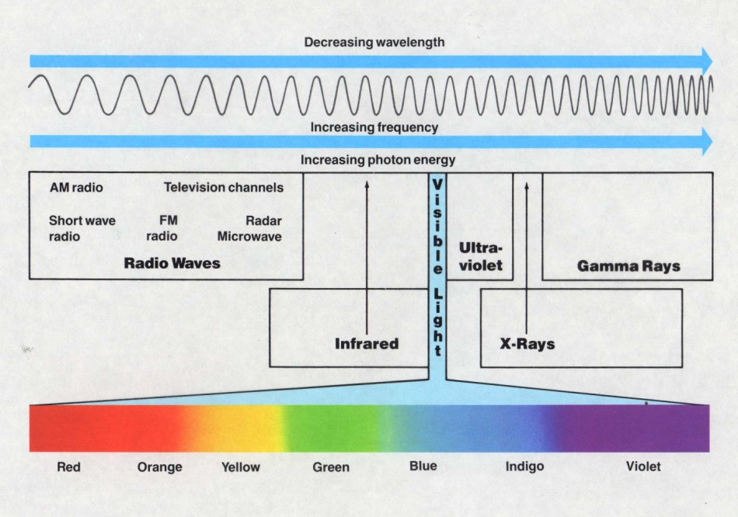

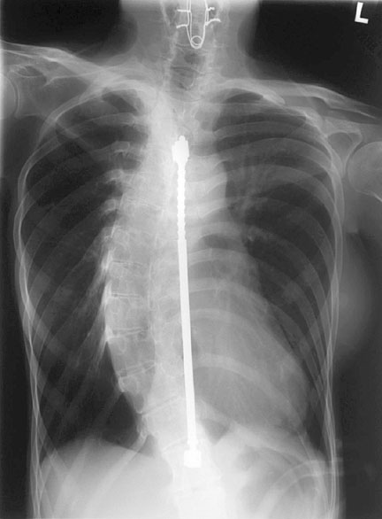sunburnConservation of Mass

**Description**: This slide illustrates a reaction between hydrogen and oxygen in a nonstoichiometric mixture of these gases.

## Basic Concepts

* Mass and atoms are conserved in chemical reactions.
* When non-stoichiometric quantities of substances are mixed, they react in stoichiometric proportions. Any reactants in excess remain unreacted.

# Teaching Suggestions

Explain that the first diagram shows the amount of oxygen and hydrogen in a closed chamber. A spark passes between the electrodes, causing the O2 and H2 to react rapidly. The second diagram shows what is in the chamber after the reaction.

Use this slide to illustrate that reactants combine in the stoichiometric proportions. Stress that is is not sufficient to know the amounts of starting materials present. One must also know the amounts of reactants that will take part in the reaction.

# Questions

1. What is the ratio of the mass of O2 to H2 before the reaction?
2. What is the ratio of the number of moles of O2 to H2 before the reaction?
3. How do you account for the fact that the mass of the chamber and its contents is the same before and after the reaction.
4. Why is some oxygen left in the chamber after the reaction?
5. What are the masses of H2 and O2 that take part in the reaction?
6. What is the ratio of the mass of O2 to H2 taking part in this reaction? What is the ratio of the number of moles of O2 to H2 taking part in the reaction? Why is this mole ratio different from the mass ratio?
7. If there were twice as much H2 in the chamber (10 g) but the same amount of O2 (80g), what would you expect to find in the chamber after the reaction? Explain your answer.

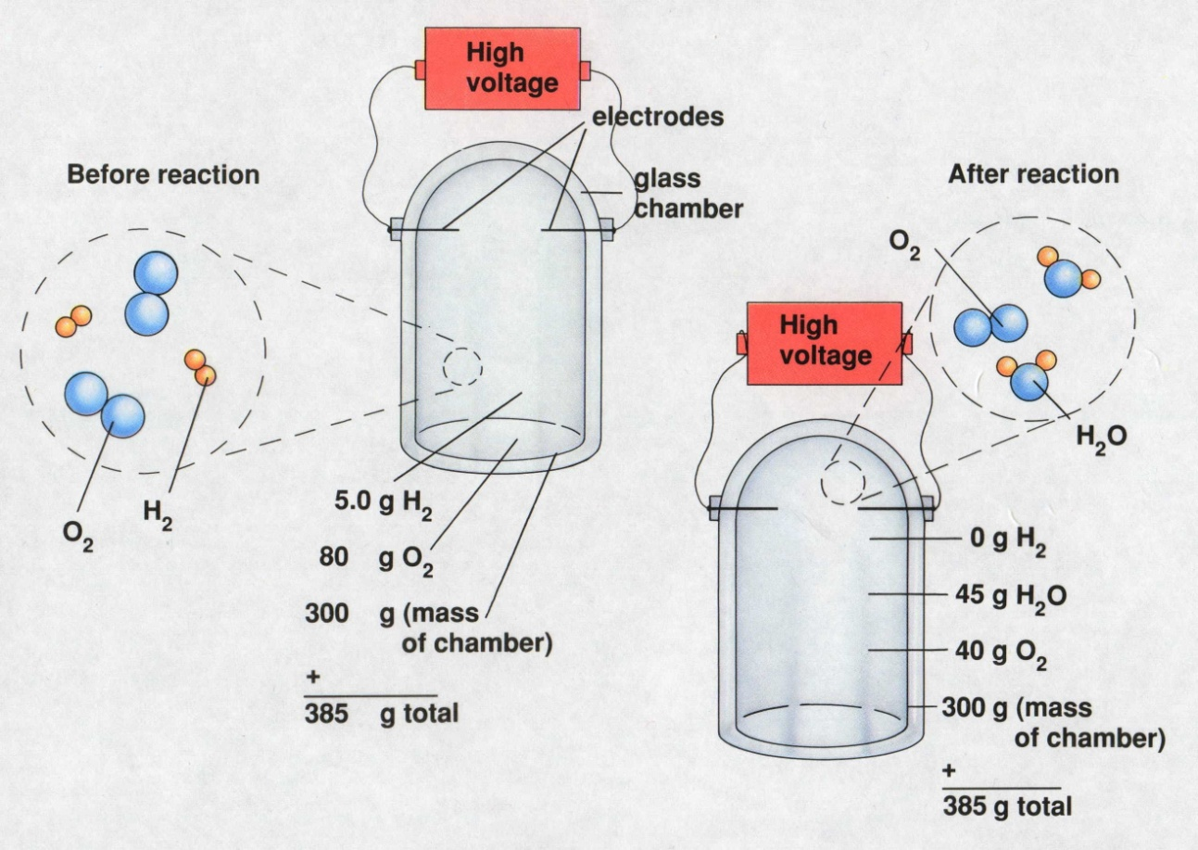

Conservation of Atoms

**Description**: This slide illustrates conservation of atoms in a chemical reaction.

# Basic Concepts

* Atoms are conserved in chemical reactions, but molecules are not.
* Atoms are neither created nor destroyed in chemical reactions. They are only rearranged.
* Equation coefficients can be interpreted as the relative numbers of molecules, formula units, or moles of reactants and products.

# Teaching Suggestions

This slide shows that atoms are neither created nor destroyed in a chemical reaction but are merely rearranged. Use this slide and worksheet to help students understand formula equations. You may need to review how gram formula mass is determined.

# Questions

1. State the law that explains why the number of oxygen and hydrogen atoms is the same on both sides of the equation shown in the diagram.
2. In what ways are the atoms rearranged by the reaction?
3. Write a word equation for the reaction taking place in the diagram.
4. In the balanced equation shown in the diagram, what is the coefficient of H2? Of O2? Give two ways in which the coefficients in the balanced equation can be interpreted.
5. Use the balanced equation to determine how many moles of H2O would be produced by the reaction of 4 moles of H2 with 2 moles of O2.
6. The gram formula mass of a substance is the number of grams of the substance containing a mole of formula units.
   1. Write the equation for the reaction in question 5 showing the number of moles of the reactants and the product.
   2. Calculate the gram formula mass of H2, O2, and H2O.
   3. How many grams of H2 and O2 react in the reaction in part a? How many grams of H2O are produced?
   4. Rewrite the equation, giving the masses of reactants and products. How do you know that mass is conserved in this reaction?
   5. Do the masses of the reactants in the equation in part d have the same ratio as the coefficients of the equation in part a? Why or why not?
7. Which do you think is most useful to a chemist: the balanced formula equation (at the top of the diagram), the molecular sketch, the word equation, or an equation that gives the masses of reactants and products? Which would be the least useful? Explain your reasoning.

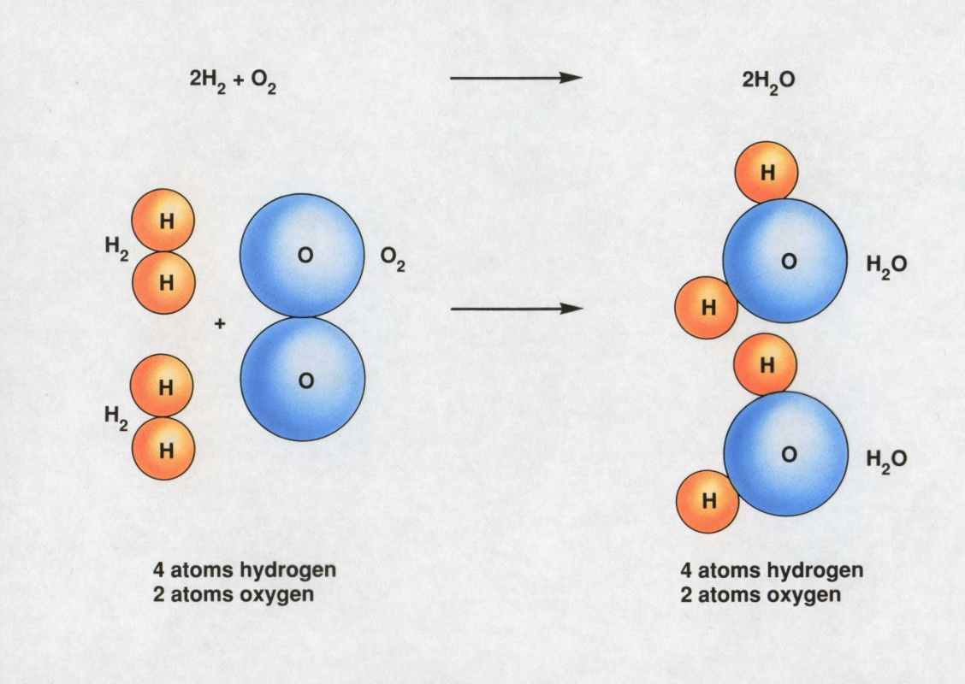

A Distillation Apparatus

**Description**: This transparency shows an apparatus used for laboratory distillations.

# Basic Concepts

* The separation of substances by distillation occurs because the boiling point of the substances differ. The substance with the lowest boiling point boils away first.
* Distillation is based on the principle that a substance will change from a liquid to a vapor during heating and from a vapor back to a liquid while cooling.

# Teaching Strategies

Use this slide to explain to students how a distillation apparatus is used to purify liquids and to separate the components of liquid mixtures. Begin by reviewing the phases of matter, stressing the processes of evaporation and condensation. Remind students that different liquids have different boiling points. Point out that substances that are solids at room temperature usually have higher boiling points than do substances that are liquids at room temperature.

# Questions

1. If the distilling flask shown in the diagram were open to the air (rather than being connected to the condensor), what would happen to each component of the mixture in the flask as boiling continued?
2. Explain your answer to question 1 in terms of the boiling points of the liquid and the dissolved solid.
3. In the distillation apparatus, the vaporized liquid must enter the condenser. The condenser consists of a long tube within another tube (the jacket). The substance in the central tube and the jacket cannot mix. Cold water enters at the bottom of the jacket and exits at the top.
   1. What is the function of the condenser jacket?
   2. How would changing the length of the condenser jacket affect how well it performs this function?
4. Explain why the liquid entering the receiving flask is pure.
5. To separate a mixture of methanol and water, you set up a distillation apparatus and heat the mixture to the boiling point of methanol, 65 oC.
   1. What substance would you expect to collect at the receiving flask?
   2. When you finish the experiment, you discover that the substance in the receiving flask is not pure. It still contains both water and methanol. Can you explain why? (Hint: Think about vapor pressures.)
6. Before automobiles were invented, crude petroleum was used mainly as a source of kerosene. The petroleum was heated in a device called a still. Gasoline, then considered to be useless, evaporated first into the air. Kerosene boiled off next and was condensed and collected. A tar-like residue remained in the still. From this information, what can you deduce about the boiling points of gasoline, kerosene, and the residue?
7. How will you know when all of one component has been separated?

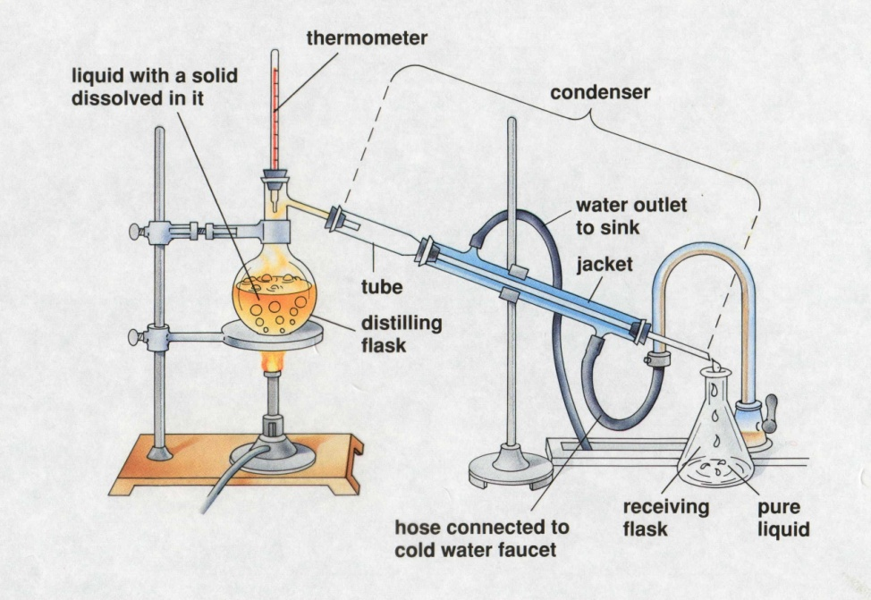

The Kinetic Theory and the Gas Laws

**Description**: This slide shows three cylinders filled with equal masses of the same gas under different conditions. In cylinder (b), the pressure and temperature both have doubled from their values in cylinder (a). In cylinder (c), only the temperature has been doubled. The velocities of the gas particles are represented graphically to help students interpret the macroscopic changes in terms of the kinetic theory.

# Basic Concepts

* The kinetic theory can explain the combined gas law relationships of an ideal gas.
* The pressure of a confined gas increases when the particles of the gas collide with the container walls more frequently or with greater force.

# Teaching Suggestions

Use this slide to review the kinetic theory as it applies to the temperature, volume, and pressure of gases. Ask students whether the velocities of the gas particles would be the same for all gases at the same temperature. Point out that the average kinetic energy would be the same for all gases, but more massive gas particles would have slower velocities because mass and velocity are inversely proportional in the formula for kinetic energy: ½ *mv2*.

# Questions

1. The three cylinders in the diagram contain equal masses of the same gas under different conditions. Compare and contrast the conditions of the gas in each of the cylinders with respect to the pressure, volume, and temperature of the gas.
2. Cylinder (b) illustrates what happens when the gas in cylinder (a) is heated at constant volume. What happens to the average kinetic energy of the gas particles? How does this affect the velocity of the particles?
3. Use the kinetic theory to explain why the internal gas pressure in cylinder (b) is greater than the internal gas pressure in cylinder (a). What has been done to cylinder (b) to keep the gas volume the same as in cylinder (a)? Explain in terms of the equilibrium between internal and external pressure.
4. Suppose you are given the information that the temperature in both cylinder (b) and cylinder c) is double the temperature in cylinder (a). Compared with cylinder (a), how much greater is the volume in cylinder (c)? Explain how your answers illustrate the combined gas law (*PV/T* = constant).
5. Predict what would happen if you doubled the mass on top of the piston in cylinder (a), with the temperature constant. Use the kinetic theory to describe how this change would affect each of the following: volume, density, temperature, average velocity of the particles, rate of collision of the particles with the container wall, energy of these collisions, and internal pressure.
6. Suppose you take a basketball outside on a cold winter day. At first the basketball bounces normally, but then you notice that it starts to lose some of its bounce. Use the kinetic theory of gases to explain what is happening. Think of a few explanations. How could you determine which explanation is the best one?

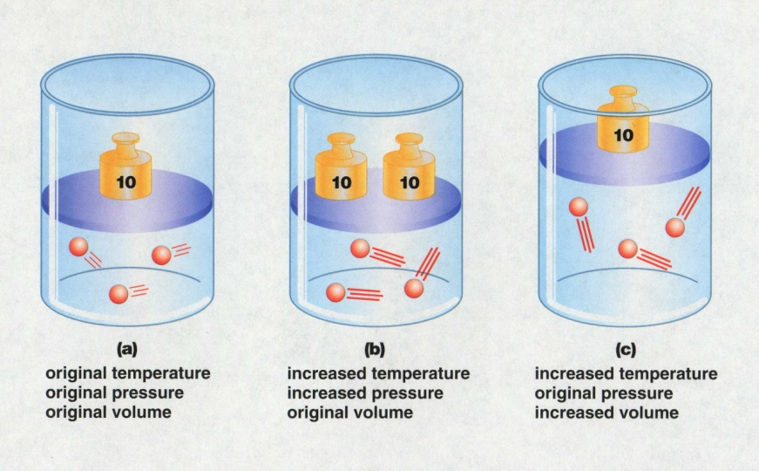Solubility Curves for Selected Solutes

**Description**: This slide is a graph of solubility curves for 10 solutes. It shows the number of grams of solute that will dissolve in 100 grams of water over a temperature range of 0cC to 10 cC.

# Basic Concepts

* The maximum amount of solute that will dissolve at a given temperature in 100 grams of water is given by the solubility curve for that substance.
* When the temperature of a saturated solution decreases, a precipitate forms.
* Most solids become more soluble in water as temperature increases, whereas gases become less soluble as temperature increases.

# Teaching Suggestions

Use this slide to teach students how to use solubility curves to determine the solubilities of various substances at different temperatures. Direct their attention to the dashed lines; these can be used to find the solubility of KClO3 at 50 cC (about 21 g per 100 g of H2O). Make sure students understand that a point on a solubility curve represents the *maximum* quantity of a particular solute that can be dissolved in a specified quantity of solvent or solution at a *particular* temperature. Point out that the solubility curve for a particular solute does not depend on whether other solutes also are present in the solution (unless there is a common-ion effect; this subject usually is covered at a later stage in a chemistry course).

# Questions

1. Determine the solubilities (in water) of the following substance at the indicated temperatures: NH3 at 50 oC; KCl at 90 oC; and NaNO3 at 0 oC.
2. Which of the substances shown on the graph is most soluble in water at 20 oC? Which is lease soluble at that temperature? For which substance is the solubility lease affected by changes in temperature?
3. Why do you think solubilities are only shown between 0 oC and 100 oC?
4. In a flask, you heat a mixture of 120 grams of KClO3 and 300 grams of water until all of the KClO3 has just been dissolved. At what temperature does this occur? You then allow the flask to cool. When you examine it later, the temperature is 64 oC and you notice a white powder in the solution. What has happened? What is the mass of the white powder?
5. Compare the solubility curves for the gases HCl, NH3, and SO2) with the solubility curves for the solid solutes. What generalizations(s) can you make about the relationship between solubility and temperature?
6. 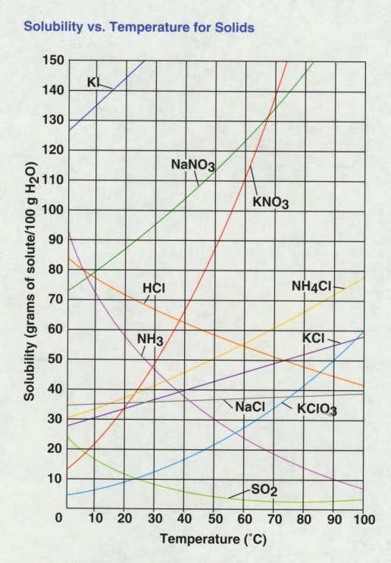According to an article in an engineering journal, there is a salt whose solubility in water increases as the water temperature increases from 0 oC to 65 oC. The salt’s solubility then decreases at temperatures above 65 oC, the article states. In your opinion, is such a salt likely to exist? Explain your answer. What could you do to verify the claims of the article?

Aspirin Organic Synthesis

**Description**: This slide show the synthesis of aspirin from benzene. The structural formulas are given instead of the condensed formulas.

# Visual Strategy

Point out how the depiction of an organic synthesis differs from the way students have traditionally seen reactions represented. Write the equation for the formation of water on the board.

# Questions

1. How does the synthesis shown differ from the equation for the formation of water?
2. What are the structural similarities among all intermediates in the synthesis?

Symbolic Representations of Benzene

**Description**: This slide illustrates the ways in which chemist represent the benzene molecule.

# Visual Strategy

This slide shows students how chemists represent substances. Because organic structures are very common, students must develop skill in interpreting organic structures.

# Questions

1. What is the chemical formula for benzene?
2. What is the chemical formula for phenol?
3. Using what you know about the formula for benzene, determine the chemical formula for aspirin from the structure on the previous slide?

Reporting Measurements Using Significant Figures

**Description**: This slide illustrates the last digit in a measurement is an estimate.

# Visual Strategy

In applying the rules for significant figures, many students lose sight of the fact that the concept of significant figures comes from estimations in measurements. The last digit in a measurement is an estimation.

# Questions

1. How could the measurement be affected by the use of several different rulers to measure the nail?
2. Why is it important to use the same measuring instrument throughout an experiment.
3. Is the nail 6.3 cm, 6.35 cm, 6.4 cm? Explain.
4. Is an answer for the measurement of the nail 6.350 more *accurate* than 6.37? Explain. [Review accuracy vs. precision]
5. Does adding more digits to a measurement increase the accuracy of the measurement?